PRACTICAL DRAWING SHEET | Reach for the Star

Congruence and geometric reasoning
Pearson Edexcel GCSE Mathematics 1MA1 • L027
Shared Foundation/Higher content • teacher-reviewed drawing • Lesson resources
REACH FOR THE STAR | GCSE MATHEMATICS
Use during the matching workbook tasks, not as extra compulsory work within the hour. Teaching sketches are not to scale. Draw specified lengths yourself; do not measure the printed sketch. Use additional plain paper if needed.
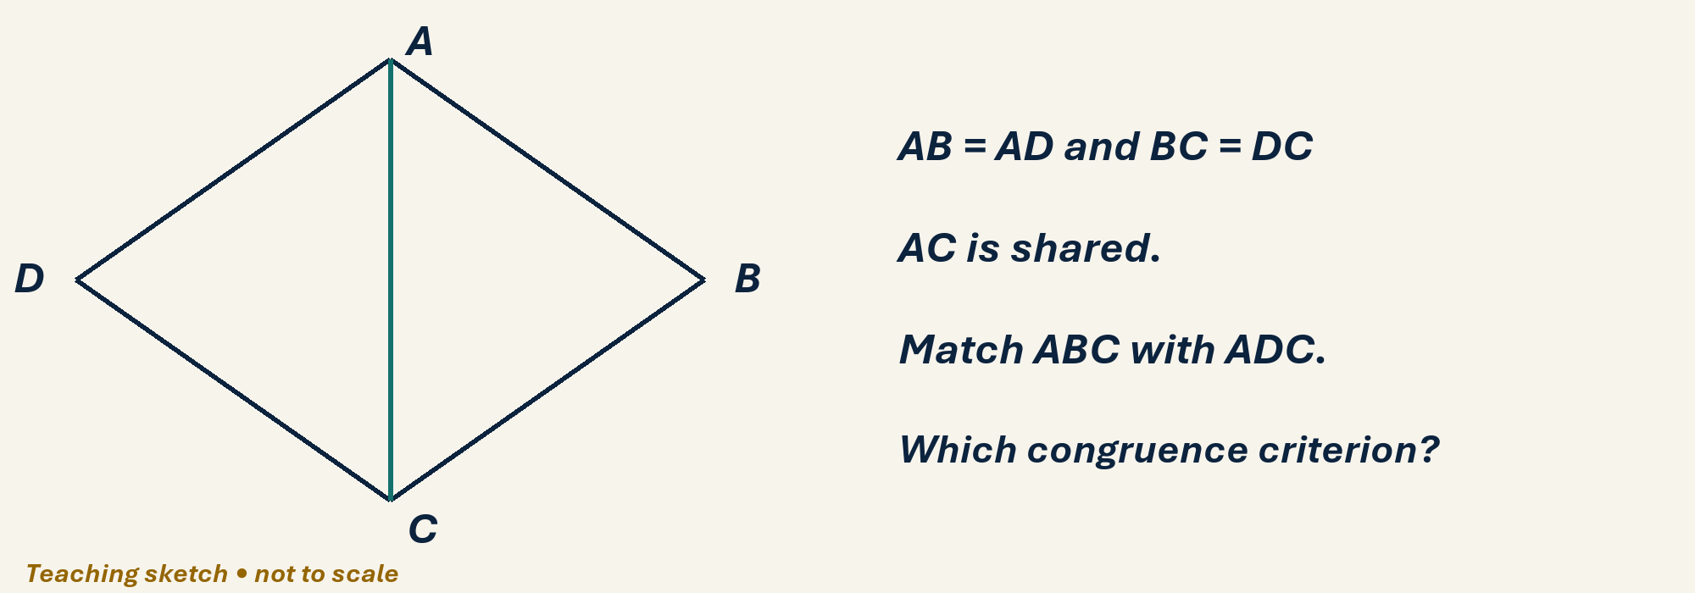

Draw, explain and check
On the kite diagram, mark AB=AD and BC=DC using different tick styles. Use the shared diagonal AC to prove triangles ABC and ADC congruent. Then prove angle BAC equals CAD. Write a reason beside every statement.
Optional scaffold: name the given facts; mark the first point or segment; explain your first step aloud. Then work without the prompt. Your teacher reviews diagrams and reasoning; there is no automatic drawing score.

Your working space
Record reasons and units. Coordinate grids: one square is one coordinate unit, regardless of printed size. For constructions or scale drawings use blank paper and draw the specified lengths with your own ruler.
______________________________________________________________________
______________________________________________________________________
______________________________________________________________________
______________________________________________________________________
______________________________________________________________________
______________________________________________________________________
______________________________________________________________________
______________________________________________________________________
______________________________________________________________________
______________________________________________________________________
______________________________________________________________________
______________________________________________________________________
______________________________________________________________________
______________________________________________________________________
______________________________________________________________________
______________________________________________________________________
Teacher feedback and fresh-check date: __________________________________

