PRACTICAL DRAWING SHEET | Reach for the Star

Constructions and loci
Pearson Edexcel GCSE Mathematics 1MA1 • L028
Shared Foundation/Higher content • teacher-reviewed drawing • Lesson resources
REACH FOR THE STAR | GCSE MATHEMATICS
Use during the matching workbook tasks, not as extra compulsory work within the hour. Teaching sketches are not to scale. Draw specified lengths yourself; do not measure the printed sketch. Use additional plain paper if needed.
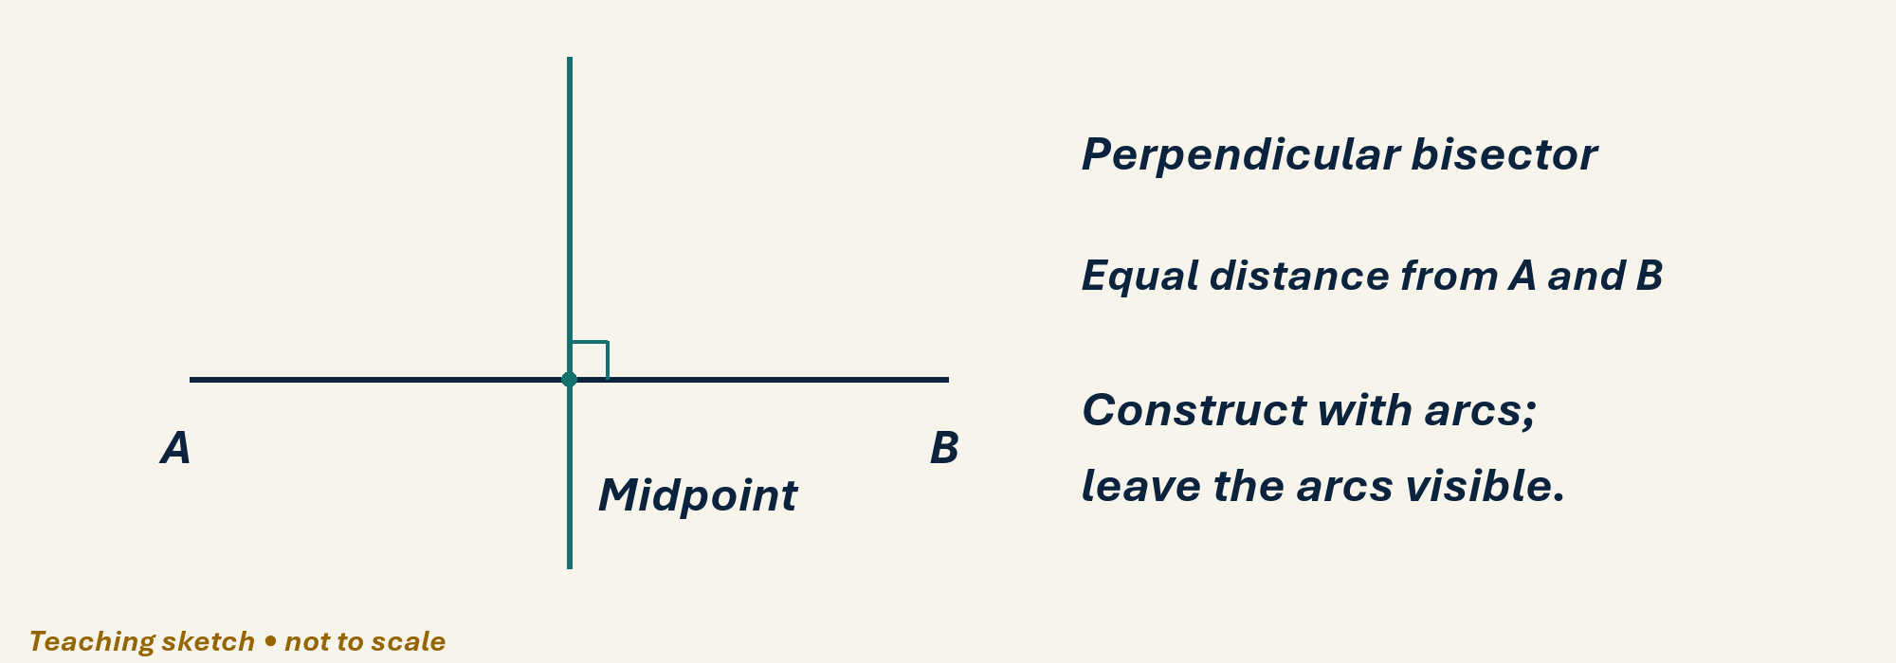

Draw, explain and check
Use a ruler and compass on blank paper. Draw AB=8 cm and construct its perpendicular bisector, leaving arcs. Construct the perpendicular to a line at a chosen point on it. Draw a 70° angle with a protractor, then bisect it with compass arcs. Finally draw two centres 6 cm apart and circles of radius 4 cm: mark points exactly 4 cm from both centres.
Optional scaffold: name the given facts; mark the first point or segment; explain your first step aloud. Then work without the prompt. Your teacher reviews diagrams and reasoning; there is no automatic drawing score.

Your working space
Record reasons and units. Coordinate grids: one square is one coordinate unit, regardless of printed size. For constructions or scale drawings use blank paper and draw the specified lengths with your own ruler.
______________________________________________________________________
______________________________________________________________________
______________________________________________________________________
______________________________________________________________________
______________________________________________________________________
______________________________________________________________________
______________________________________________________________________
______________________________________________________________________
______________________________________________________________________
______________________________________________________________________
______________________________________________________________________
______________________________________________________________________
______________________________________________________________________
______________________________________________________________________
______________________________________________________________________
______________________________________________________________________
Teacher feedback and fresh-check date: __________________________________

