PRACTICAL DRAWING SHEET | Reach for the Star

Coordinates and transformations
Pearson Edexcel GCSE Mathematics 1MA1 • L029
Shared Foundation/Higher content • teacher-reviewed drawing • Lesson resources
REACH FOR THE STAR | GCSE MATHEMATICS
Use during the matching workbook tasks, not as extra compulsory work within the hour. Teaching sketches are not to scale. Draw specified lengths yourself; do not measure the printed sketch. Use additional plain paper if needed.
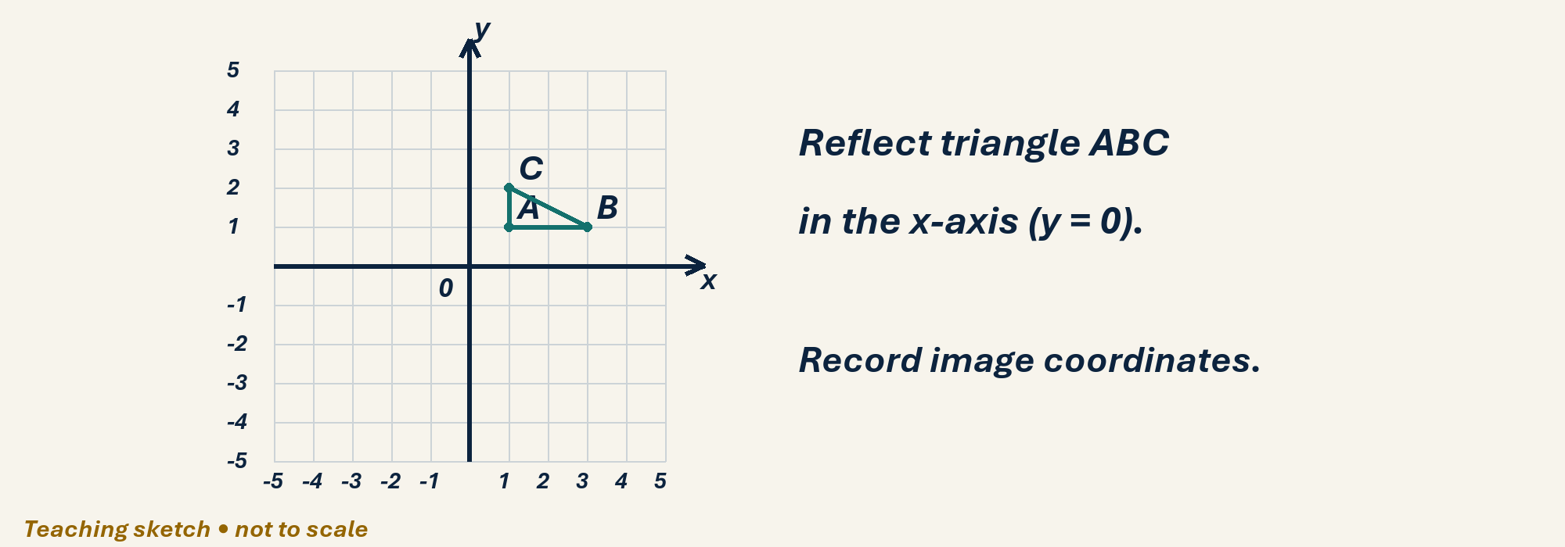

Draw, explain and check
Use the grid on page 2, one square per unit. Plot A(1,1), B(3,1), C(1,2). Reflect in y=0 and label A′, B′, C′. On a fresh grid rotate the original triangle 90° anticlockwise about the origin. Check with tracing paper and record both sets of coordinates.
Optional scaffold: name the given facts; mark the first point or segment; explain your first step aloud. Then work without the prompt. Your teacher reviews diagrams and reasoning; there is no automatic drawing score.

Your working space
Record reasons and units. Coordinate grids: one square is one coordinate unit, regardless of printed size. For constructions or scale drawings use blank paper and draw the specified lengths with your own ruler.
Teacher feedback and fresh-check date: __________________________________

