PRACTICAL DRAWING SHEET | Reach for the Star

Geometry checkpoint and feedback
Pearson Edexcel GCSE Mathematics 1MA1 • L032
Shared Foundation/Higher content • teacher-reviewed drawing • Lesson resources
REACH FOR THE STAR | GCSE MATHEMATICS
Use during the matching workbook tasks, not as extra compulsory work within the hour. Teaching sketches are not to scale. Draw specified lengths yourself; do not measure the printed sketch. Use additional plain paper if needed.
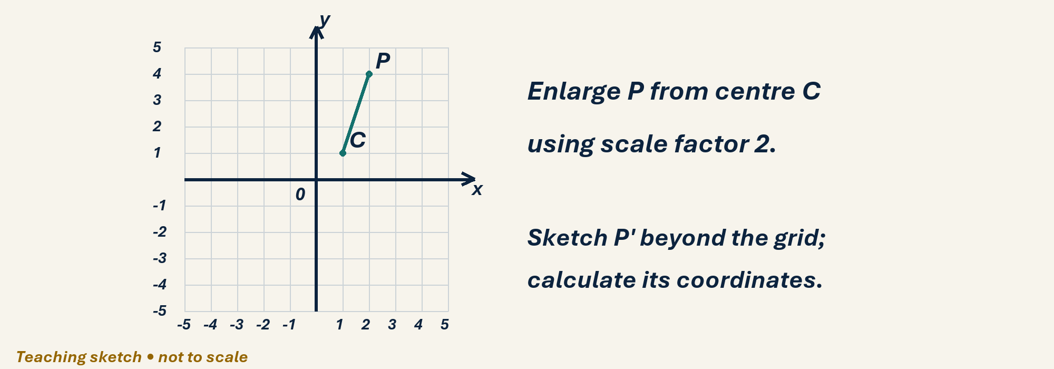

Draw, explain and check
Without the worked examples, construct the perpendicular bisector of a 6 cm segment using ruler and compass. Then plot C(1,1), P(2,4) on a fresh grid and enlarge P by factor 2 about C. Extend your axes as needed. Write how each answer can be checked.
Optional scaffold: name the given facts; mark the first point or segment; explain your first step aloud. Then work without the prompt. Your teacher reviews diagrams and reasoning; there is no automatic drawing score.

Your working space
Record reasons and units. Coordinate grids: one square is one coordinate unit, regardless of printed size. For constructions or scale drawings use blank paper and draw the specified lengths with your own ruler.
Teacher feedback and fresh-check date: __________________________________

