PRACTICAL DRAWING SHEET | Reach for the Star

Circles arcs and sectors
Pearson Edexcel GCSE Mathematics 1MA1 • L034
Shared Foundation/Higher content • teacher-reviewed drawing • Lesson resources
REACH FOR THE STAR | GCSE MATHEMATICS
Use during the matching workbook tasks, not as extra compulsory work within the hour. Teaching sketches are not to scale. Draw specified lengths yourself; do not measure the printed sketch. Use additional plain paper if needed.
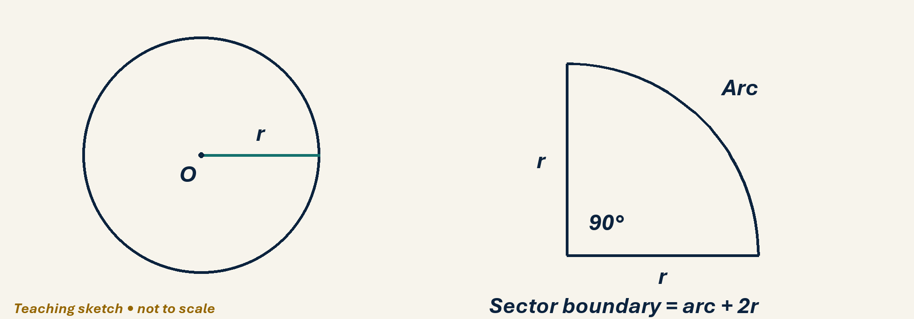

Draw, explain and check
With compass and ruler, draw radius 4 cm and make a 90° sector using a protractor. Colour the arc, then mark both radii. Find exact sector area and full perimeter. Explain why these have different units. For the pond question A3, use the π key and round only at the end.
Optional scaffold: name the given facts; mark the first point or segment; explain your first step aloud. Then work without the prompt. Your teacher reviews diagrams and reasoning; there is no automatic drawing score.

Your working space
Record reasons and units. Coordinate grids: one square is one coordinate unit, regardless of printed size. For constructions or scale drawings use blank paper and draw the specified lengths with your own ruler.
______________________________________________________________________
______________________________________________________________________
______________________________________________________________________
______________________________________________________________________
______________________________________________________________________
______________________________________________________________________
______________________________________________________________________
______________________________________________________________________
______________________________________________________________________
______________________________________________________________________
______________________________________________________________________
______________________________________________________________________
______________________________________________________________________
______________________________________________________________________
______________________________________________________________________
______________________________________________________________________
Teacher feedback and fresh-check date: __________________________________

