

Knowledge organiser · Surface area and volume
GCSE Mathematics 1MA1 · L036 · 60 minutes

Core distinction
Quantity | Meaning | Units
Surface area | Total exposed area of all required faces | cm², m²
Volume | Space occupied / capacity of a solid | cm³, m³

Formulae and structures
- Cuboid volume: V = lwh
- Cuboid total surface area: SA = 2(lw + lh + wh)
- Prism volume: V = cross-sectional area × length
- Cylinder volume: V = πr²h
- Closed cylinder total surface area: SA = 2πr² + 2πrh
- Open-top solid: omit the missing face from surface area, but not from volume.
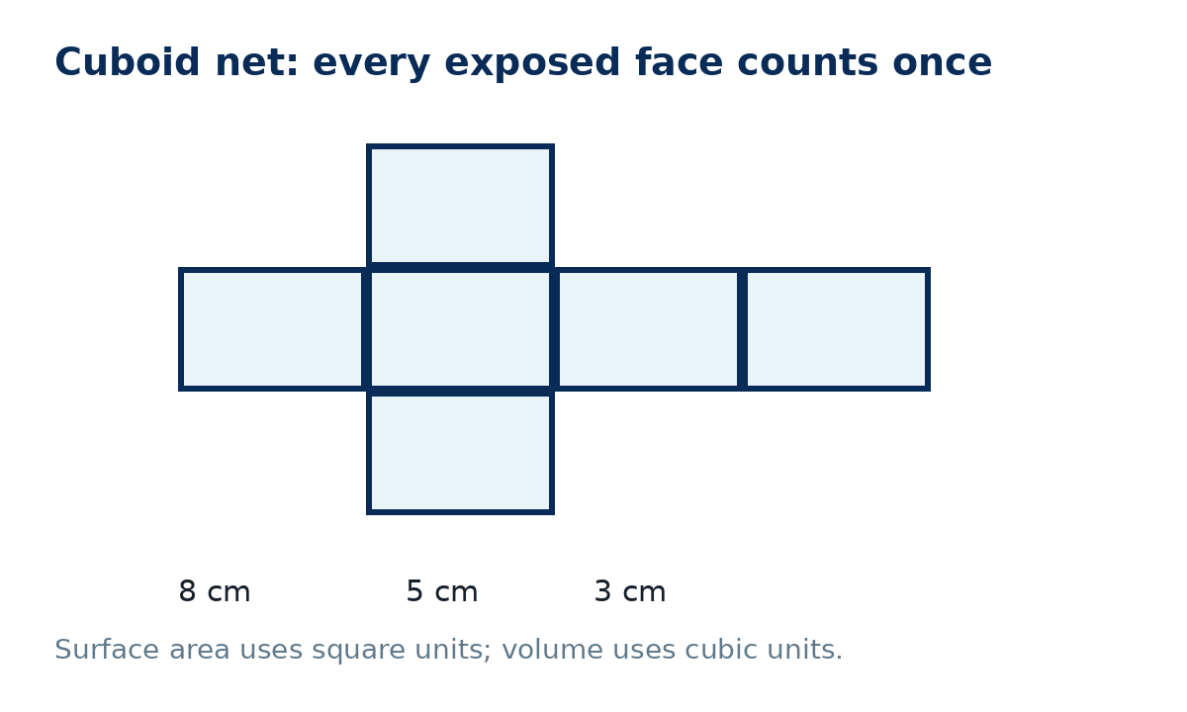
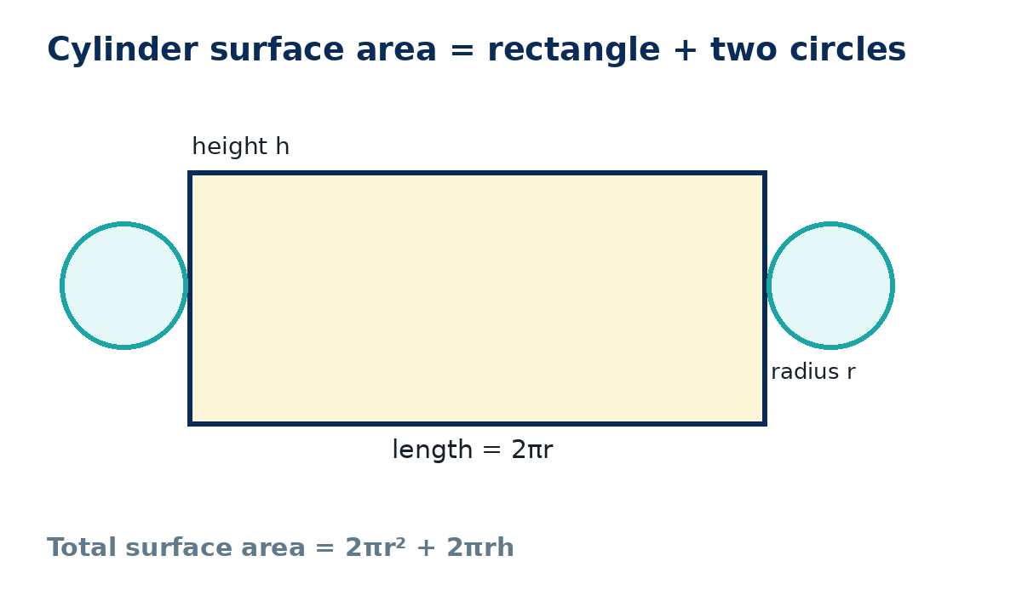

Method checklist
- Sketch or recognise the net / faces.
- Decide whether the question asks for area, volume, or both.
- Check whether the solid is open or closed.
- Substitute dimensions with units.
- For calculator work, keep full precision until the end.
- Check: surface area must be square units; volume must be cubic units.

Common errors to avoid
Missing a face; counting an internal/non-exposed face; using diameter as radius; using cm² for volume; rounding π too early; using 2πrh alone for a closed cylinder.

