

Surface area and volume
GCSE Mathematics 1MA1 · L036 · 60 minutes
Objective: Find surface area and volume using appropriate nets and formulae, and explain the difference between exposed area and capacity.
Calculator conditions: questions are labelled NC (non-calculator) or C (calculator). Use exact π unless a decimal answer is requested.
Connect & Check  5 min | Complete the baseline independently. Keep your first response so you can compare it with the exit task.

C1. A cuboid measures 8 cm by 5 cm by 3 cm. Find its volume. [NC] [2 marks]
________________________________________________________________________________
________________________________________________________________________________
C2. What is the difference between surface area and volume? Include the correct type of units for each. [NC] [2 marks]
________________________________________________________________________________
________________________________________________________________________________
________________________________________________________________________________
Share  5 min | Choose one route below. All routes lead to the same core evidence. Compare your route with a partner before you move on.

Route | What you do | Evidence you produce
A · Visual | Sketch or label a net before calculating. | A labelled net + calculation.
B · Method | Use a formula/face table and explain each term. | A clear method + units.
C · Explain | Start by explaining which faces count and why. | A written justification + calculation.

Present  12 min | Study the two models. Annotate the images and complete the worked examples with the teacher.

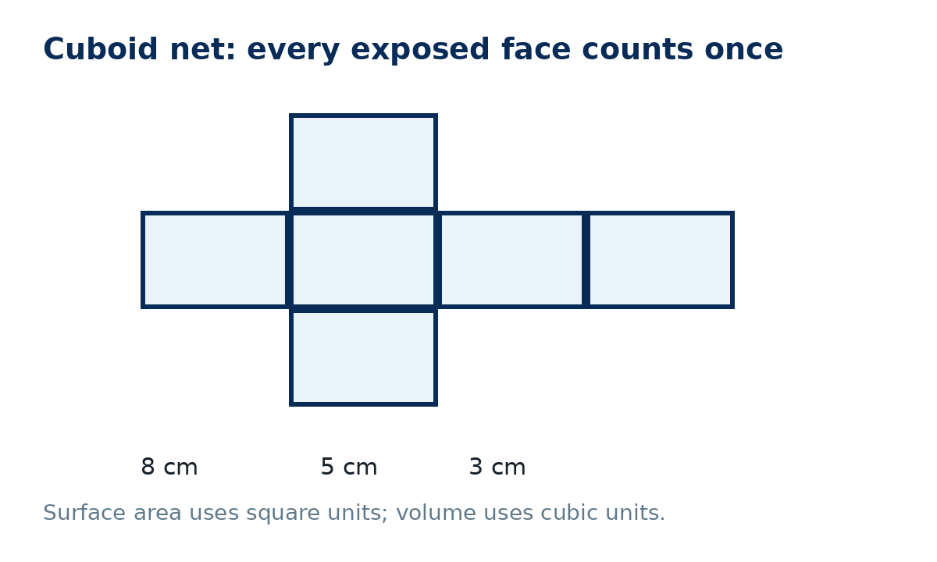
P1. For an 8 cm by 5 cm by 3 cm cuboid, complete: surface area = 2(8×5 + 8×3 + 5×3) = ______ cm². Then check the volume. [NC] [3 marks]
________________________________________________________________________________
________________________________________________________________________________
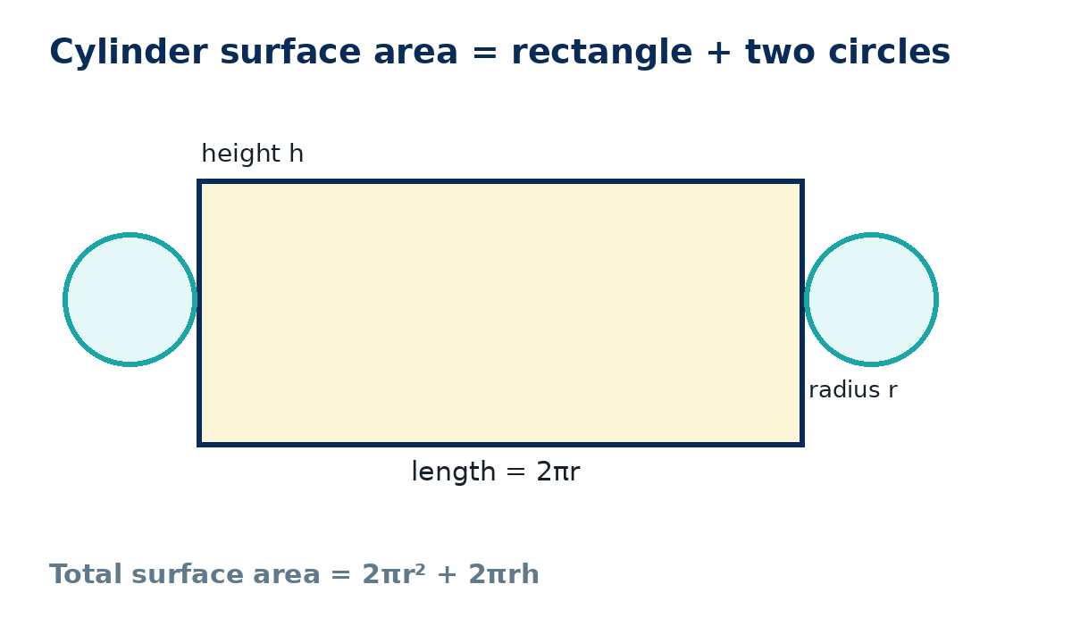
P2. A closed cylinder has radius 4 cm and height 9 cm. Write an exact expression for its total surface area and volume. [C] [4 marks]
________________________________________________________________________________
________________________________________________________________________________
________________________________________________________________________________
Apply  25 min | Complete the supported questions first. Then remove the scaffold and complete the independent and exam-style questions.

Supported practice
A1. A cuboid is 10 cm long, 6 cm wide and 4 cm high. Use the face-pair structure 2(lw + lh + wh) to find the total surface area. [NC] [3 marks]
________________________________________________________________________________
________________________________________________________________________________
________________________________________________________________________________
A2. The same cuboid has volume 240 cm³. Explain why the units are cm³ rather than cm². [NC] [2 marks]
________________________________________________________________________________
________________________________________________________________________________
________________________________________________________________________________

Independent practice - scaffold removed
A3. A closed cylinder has radius 3.5 cm and height 12 cm. Find its total surface area and volume. Give each answer to 1 decimal place. [C] [6 marks]
________________________________________________________________________________
________________________________________________________________________________
________________________________________________________________________________
________________________________________________________________________________
________________________________________________________________________________
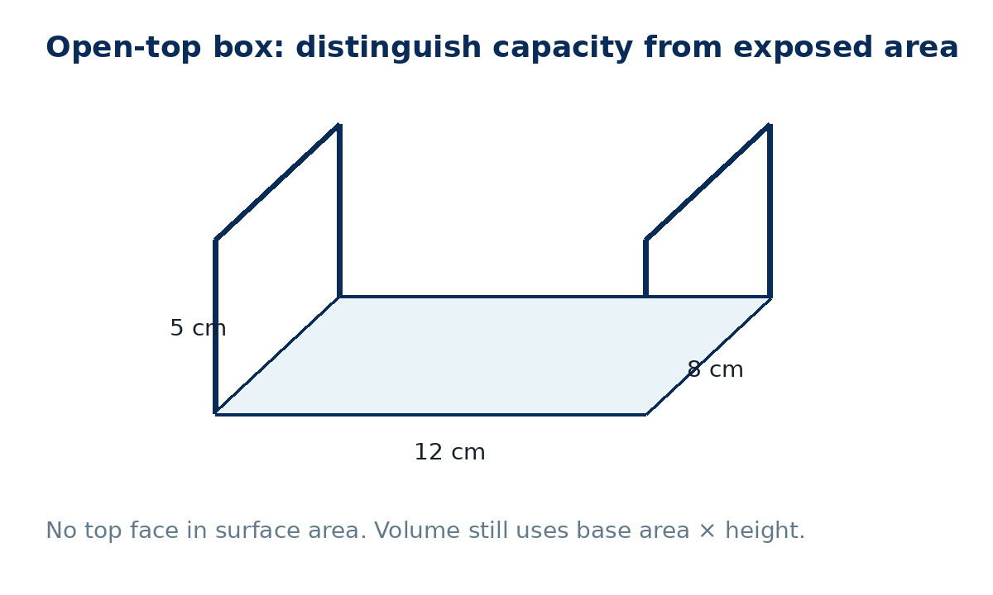
A4. An open-top box measures 12 cm by 8 cm by 5 cm. Find (a) its exposed surface area and (b) its capacity in cm³. [NC] [5 marks]
________________________________________________________________________________
________________________________________________________________________________
________________________________________________________________________________
________________________________________________________________________________

Exam-style practice
E1. A solid is a closed cylinder of radius 5 cm and height 7 cm. A learner says its surface area is 2πrh because “that is the outside”. Explain the error and calculate the correct total surface area in terms of π. [C] [4 marks]
________________________________________________________________________________
________________________________________________________________________________
________________________________________________________________________________
________________________________________________________________________________
________________________________________________________________________________
E2. A cuboid has volume 360 cm³. Its base is 12 cm by 5 cm. Find its height, then find its total surface area. [NC] [5 marks]
________________________________________________________________________________
________________________________________________________________________________
________________________________________________________________________________
________________________________________________________________________________
________________________________________________________________________________

Extension and deep challenge
X1 · Stretch. A closed cuboid has volume 120 cm³ and dimensions 4 cm by 5 cm by h. Find h and then its surface area. [NC] [4 marks]
________________________________________________________________________________
________________________________________________________________________________
________________________________________________________________________________
________________________________________________________________________________
X2 · Deep challenge. A cylinder has radius r and height 2r. Express its total surface area and volume in terms of r. Compare how each changes if r is doubled. [C] [6 marks]
________________________________________________________________________________
________________________________________________________________________________
________________________________________________________________________________
________________________________________________________________________________
________________________________________________________________________________
Recall & Review  8 min | Without notes, complete the exit task. Then compare it with your Connect & Check response and write one WWW and one EBI.

R1. A closed cuboid measures 9 cm by 4 cm by 2 cm. Find both its surface area and volume, using correct units. [NC] [4 marks]
________________________________________________________________________________
________________________________________________________________________________
________________________________________________________________________________
________________________________________________________________________________
WWW: ________________________________________________________________________
EBI: ________________________________________________________________________
Next lesson preparation: Sketch the front, side and plan views of a stack of 4 cubes arranged as a 2×2 square on the base.

Recall & Review: feedback and extension integration
Lesson L036: Surface area and volume
Objective: Find surface area and volume using appropriate nets and formulae.
Timing for a 60-minute lesson
0-7 Connect & Check; 7-14 Share; 14-25 Present/model; 25-44 Apply route choice/practice; 44-52 independent exam-style check; 52-60 Recall & Review, WWW/EBI and next step.
Recall & Review evidence
At the end of the lesson, solve a fresh question without prompts, explain one check, correct one error and record the next practice step.
What Went Well (WWW)
I selected the correct geometric fact, theorem, formula or transformation and used a clear diagram with appropriate labels and units.
Even Better If (EBI)
I will name the fact or theorem, show the substitution or construction step and check whether the size, direction and units of the result are reasonable.
Integrated stretch and deep challenge
Stretch: A closed cuboid has volume 120 cm³ and dimensions 4 cm by 5 cm by h. Find h and surface area.
Deep challenge: A cylinder has radius r and height 2r. Express its total surface area and volume in terms of r.
My next-step response

