

Teacher guide · Surface area and volume
GCSE Mathematics 1MA1 · L036 · 60 minutes
Lesson objective: Find surface area and volume using appropriate nets and formulae, distinguishing exposed area from capacity.
60-minute flow: Connect & Check 5 · Share 5 · Present 12 · Apply 25 · Recall & Review 8 · feedback/transition embedded within stages.
Calculator conditions: Keep NC/C labels visible. Exact π is accepted where requested. For calculator questions, insist on full precision until the final rounding step.

Teaching sequence and misconceptions

Connect & Check
Use C1 and C2 as a baseline. Common misconception: treating surface area and volume as interchangeable, or using cm² for volume.

Share
Learners choose visual, method or explanation route. Ask pairs to identify what evidence is equivalent across routes. Do not let route choice remove the core calculation requirement.

Present
Model a cuboid by counting exposed faces from a net. For the cylinder, connect the curved surface to a rectangle of length 2πr and height h. Distinguish closed and open solids.

Apply
A1-A2 are scaffolded. Before A3, explicitly remove the face-pair/formula scaffold. A3-A4 and E1-E2 are independent. Circulate for units, omitted faces and premature rounding.

Recall & Review
R1 is fresh evidence against the objective. Compare with C1/C2. Record WWW/EBI from method and units, not only whether the final number is correct.
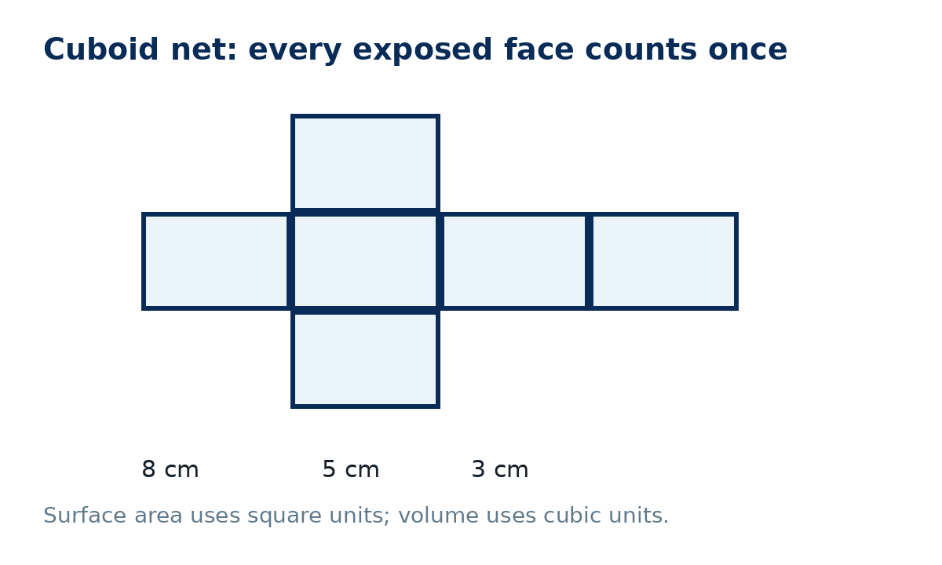
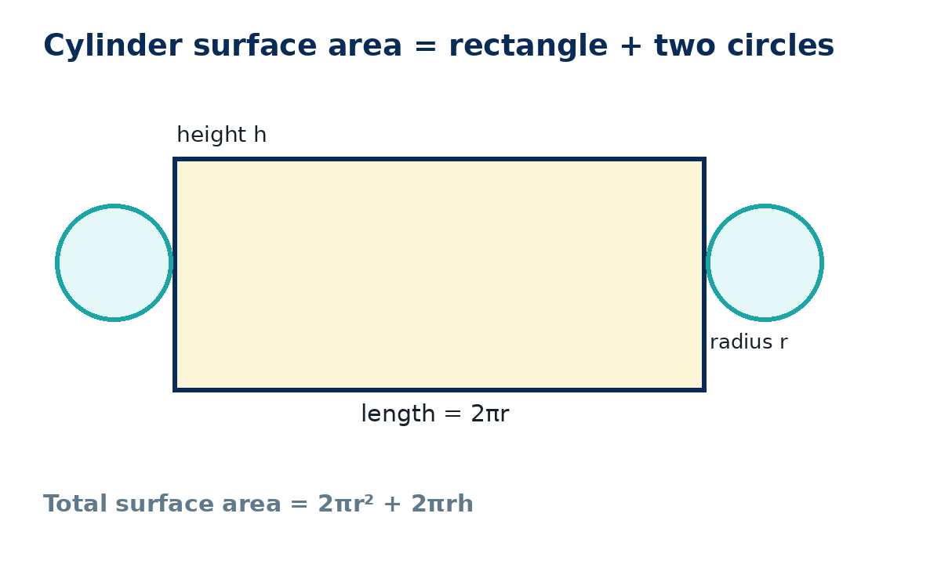
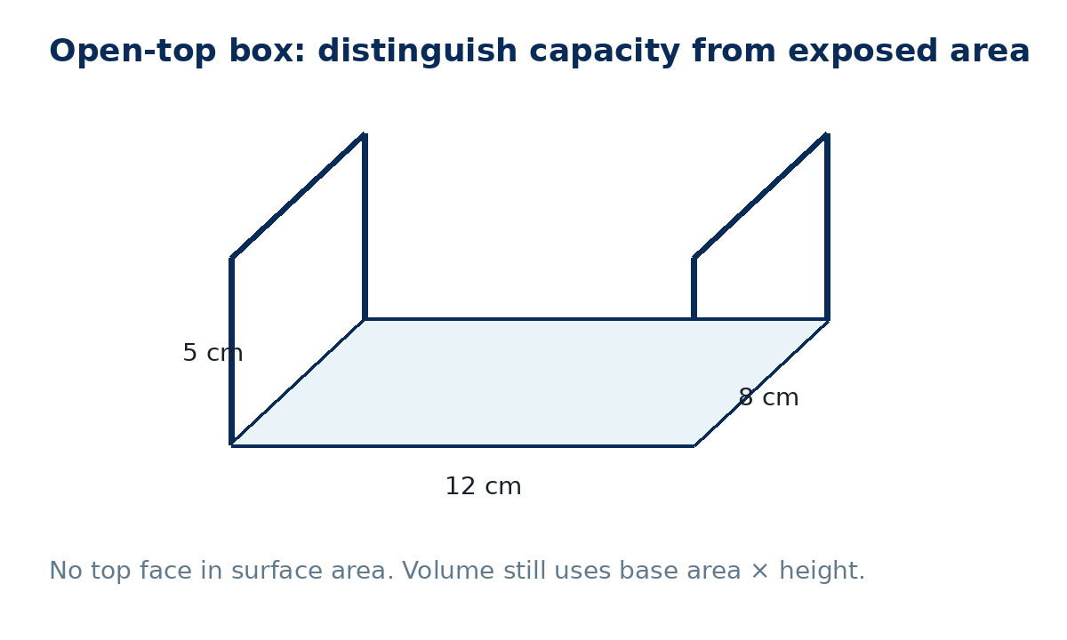

Answers and marking guidance
C1: 120 cm³ (2 marks: method/product, correct units).
C2: Surface area measures exposed faces in square units; volume measures space/capacity in cubic units.
P1: 2(40+24+15)=158 cm²; volume 120 cm³.
P2: TSA = 104π cm²; volume = 144π cm³.
A1: 2(60+40+24)=248 cm².
A2: Volume is three-dimensional, so three lengths multiply and units are cubic.
A3: TSA = 2π(3.5²)+2π(3.5)(12)=108.5π ≈ 340.9 cm²; V=π(3.5²)(12)=147π ≈ 461.8 cm³.
A4: Exposed SA = 12×8 + 2(12×5) + 2(8×5) = 296 cm²; volume = 480 cm³.
E1: The learner omitted the two circular ends. Correct TSA = 2π(5²)+2π(5)(7)=120π cm².
E2: h=360/(12×5)=6 cm; TSA=2(60+72+30)=324 cm².
X1: h=120/(4×5)=6 cm; TSA=2(20+24+30)=148 cm².
X2: TSA=2πr²+2πr(2r)=6πr²; V=πr²(2r)=2πr³. Doubling r multiplies TSA by 4 and V by 8.
R1: SA=2(36+18+8)=124 cm²; V=72 cm³.

Feedback language
WWW examples: “You identified every exposed face and used square units consistently.” “Your cylinder method clearly linked the rectangle length to the circumference.”
EBI examples: “Separate the surface-area and volume formulae before substituting.” “Check whether the solid is open or closed before counting faces.” “Keep π exact until the final step.”

Recall & Review: feedback and extension integration
Lesson L036: Surface area and volume
Objective: Find surface area and volume using appropriate nets and formulae.
Timing for a 60-minute lesson
0-7 Connect & Check; 7-14 Share; 14-25 Present/model; 25-44 Apply route choice/practice; 44-52 independent exam-style check; 52-60 Recall & Review, WWW/EBI and next step.
Recall & Review evidence
At the end of the lesson, solve a fresh question without prompts, explain one check, correct one error and record the next practice step.
What Went Well (WWW)
I selected the correct geometric fact, theorem, formula or transformation and used a clear diagram with appropriate labels and units.
Even Better If (EBI)
I will name the fact or theorem, show the substitution or construction step and check whether the size, direction and units of the result are reasonable.
Integrated stretch and deep challenge
Stretch: A closed cuboid has volume 120 cm³ and dimensions 4 cm by 5 cm by h. Find h and surface area.
Deep challenge: A cylinder has radius r and height 2r. Express its total surface area and volume in terms of r.
Teacher use
Use the What Went Well (WWW) and Even Better If (EBI) prompts to write mathematics-specific feedback linked to the objective. Do not accept generic praise: identify the method, representation, reasoning or checking step that improved, then set a fresh next-step question.
Assessment evidence to inspect: Check the formative mini-test and independent workbook response against the objective. Use the teacher answers or mark guidance; group errors for reteaching. NC/C selected to purpose; label each question.

