

Knowledge organiser · Plans, elevations and measures
GCSE Mathematics 1MA1 · L037 · 60 minutes

Core knowledge
- Plan = view from directly above.
- Elevation = straight-on orthographic view from a named direction.
- A 2D view records maximum visible extent in that direction; hidden depth may be lost.
- Scale 1:100 means 1 unit on the drawing represents 100 of the same units in reality.
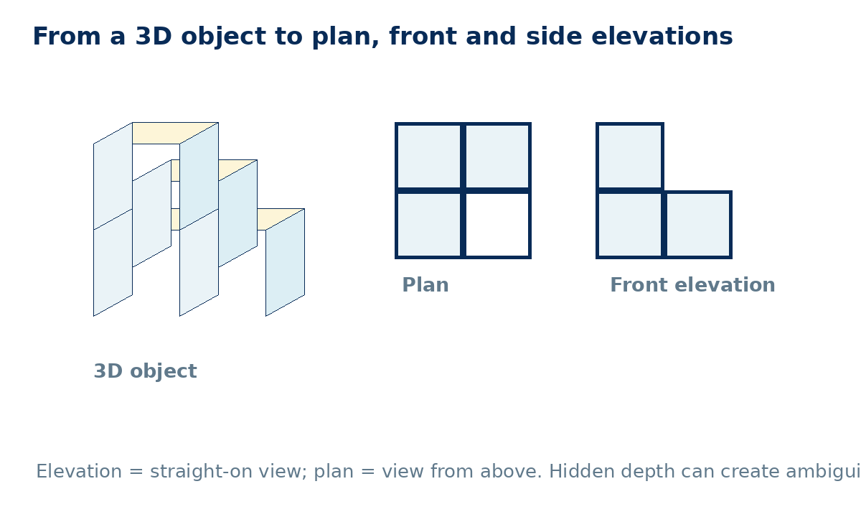

Method checklist
- Mark the viewing direction.
- Use a square grid and align widths/heights.
- For a plan, project occupied positions vertically from above.
- For an elevation, remove perspective: use straight horizontal/vertical edges.
- Check whether the information determines a unique solid.
- For scale, convert to consistent units before area calculations.

Common errors to avoid
Using perspective in an elevation; swapping front and side; assuming a plan shows height; applying the scale factor to area instead of converting lengths first.

