

Plans, elevations and measures
GCSE Mathematics 1MA1 · L037 · 60 minutes
Objective: Interpret plans and elevations and connect two-dimensional views to three-dimensional objects.
Calculator conditions: Core work is non-calculator. A calculator may be used only for a labelled scale/area check.
Connect & Check  5 min | Retrieve surface area/volume by recognising faces and viewpoints before changing representation.

C1. From above, which information about a solid can a plan show? [NC] [2 marks]
________________________________________________________________________________
________________________________________________________________________________
________________________________________________________________________________
C2. Explain the difference between a plan and a front elevation. [NC] [2 marks]
________________________________________________________________________________
________________________________________________________________________________
________________________________________________________________________________
Share  5 min | Choose a route: Visual (draw/annotate), Method (structured calculation), or Explain (justify decisions). Compare with a partner; all routes must produce the same core evidence.

Route | Journey | Evidence
A · Visual | Build or sketch the solid and draw each view. | Three labelled views.
B · Method | Use a grid and project heights/widths systematically. | Grid views with dimensions.
C · Explain | Describe what each viewpoint can and cannot reveal. | Justified interpretation.

Present  12 min | Use the model to connect the same solid to plan/front/side views. Test what becomes hidden in each projection.

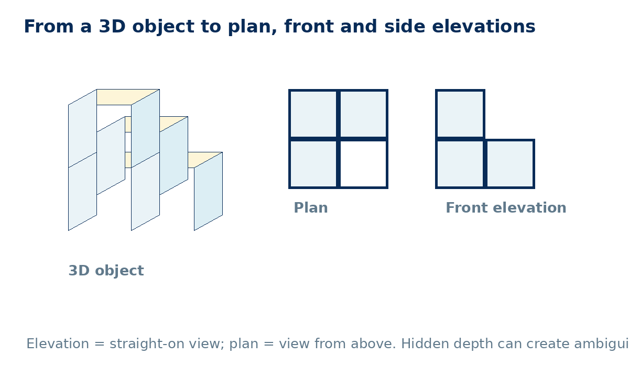
P1. For the model shown, explain why the plan does not reveal the height of the stacked column. [NC] [2 marks]
________________________________________________________________________________
________________________________________________________________________________
________________________________________________________________________________
Apply  25 min | Complete supported practice, then remove the scaffold and complete independent/exam-style work. Show a separate check where requested.

Supported practice
A1. A solid has a front elevation with column heights 2, 1 and 1. Sketch one possible arrangement of unit cubes. [NC] [3 marks]
________________________________________________________________________________
________________________________________________________________________________
________________________________________________________________________________
________________________________________________________________________________
A2. A plan occupies an L-shape of three squares. Explain what extra information is needed to determine the solid uniquely. [NC] [2 marks]
________________________________________________________________________________
________________________________________________________________________________
________________________________________________________________________________

Independent practice - scaffold removed
A3. Draw the plan, front elevation and side elevation of a 2×2 base where one corner has a second cube stacked on top. [NC] [6 marks]
________________________________________________________________________________
________________________________________________________________________________
________________________________________________________________________________
________________________________________________________________________________
________________________________________________________________________________
________________________________________________________________________________
A4. Two solids have the same front elevation. Give one reason their plans might differ. [NC] [2 marks]
________________________________________________________________________________
________________________________________________________________________________
________________________________________________________________________________

Exam-style practice
E1. A rectangular room measures 6 cm by 4 cm on a 1:100 plan. Find the real floor area in m². [C] [4 marks]
________________________________________________________________________________
________________________________________________________________________________
________________________________________________________________________________
________________________________________________________________________________
________________________________________________________________________________
E2. A solid has identical front and side elevations, each two squares wide and two squares high. Must the plan be a 2×2 square? Explain with a counterexample or convincing description. [NC] [4 marks]
________________________________________________________________________________
________________________________________________________________________________
________________________________________________________________________________
________________________________________________________________________________
________________________________________________________________________________

Extension and deep challenge
X1. Sketch two different solids that have the same front elevation but different side elevations. [NC] [4 marks]
________________________________________________________________________________
________________________________________________________________________________
________________________________________________________________________________
________________________________________________________________________________
________________________________________________________________________________
X2. Two solids have identical front and side elevations. Must their plans be identical? Explain using a specific arrangement of cubes. [NC] [5 marks]
________________________________________________________________________________
________________________________________________________________________________
________________________________________________________________________________
________________________________________________________________________________
________________________________________________________________________________
Recall & Review  8 min | Complete the exit task without notes, compare with your baseline and record one WWW and one EBI.

R1. A solid is made from four cubes: three form an L-shape on the base and one is stacked on the corner cube. Describe or sketch its plan and front elevation. [NC] [4 marks]
________________________________________________________________________________
________________________________________________________________________________
________________________________________________________________________________
________________________________________________________________________________
________________________________________________________________________________
WWW: ________________________________________________________________________
EBI: __________________________________________________________________________
Next lesson preparation: Review square numbers 1² to 15² and identify the hypotenuse in three right-angled triangles.

Recall & Review: feedback and extension integration
Lesson L037: Plans elevations and measures
Objective: Interpret plans and elevations and connect views to three-dimensional objects.
Timing for a 60-minute lesson
0-7 Connect & Check; 7-14 Share; 14-25 Present/model; 25-44 Apply route choice/practice; 44-52 independent exam-style check; 52-60 Recall & Review, WWW/EBI and next step.
Recall & Review evidence
At the end of the lesson, solve a fresh question without prompts, explain one check, correct one error and record the next practice step.
What Went Well (WWW)
I selected the correct geometric fact, theorem, formula or transformation and used a clear diagram with appropriate labels and units.
Even Better If (EBI)
I will name the fact or theorem, show the substitution or construction step and check whether the size, direction and units of the result are reasonable.
Integrated stretch and deep challenge
Stretch: A scale plan measures 6 cm by 4 cm at 1:100. Find the real floor area in m².
Deep challenge: Two solids have identical front and side elevations. Must their plans be identical? Explain with an example.
My next-step response

