

Teacher guide · Plans, elevations and measures
GCSE Mathematics 1MA1 · L037 · 60 minutes
Lesson objective: Interpret plans and elevations and connect two-dimensional views to three-dimensional objects.
60-minute flow: Connect & Check 5 · Share 5 · Present 12 · Apply 25 · Recall & Review 8 · feedback embedded.
Calculator conditions: Core work is non-calculator. A calculator may be used only for a labelled scale/area check.

Teaching sequence and misconceptions

Connect & Check
Check viewpoint language. Learners often confuse “front” with the face drawn nearest them in an isometric sketch.

Share
Route choice may use manipulatives, sketching or verbal reasoning, but everyone must produce interpretable orthographic evidence.

Present
Project vertically for a plan and horizontally for elevations. Emphasise that hidden depth/height can make a view ambiguous.

Apply
Remove physical models before A3 so the independent evidence is representational rather than copied.

Recall & Review
Accept accurate labelled sketches or precise descriptions. Compare with baseline viewpoint language.
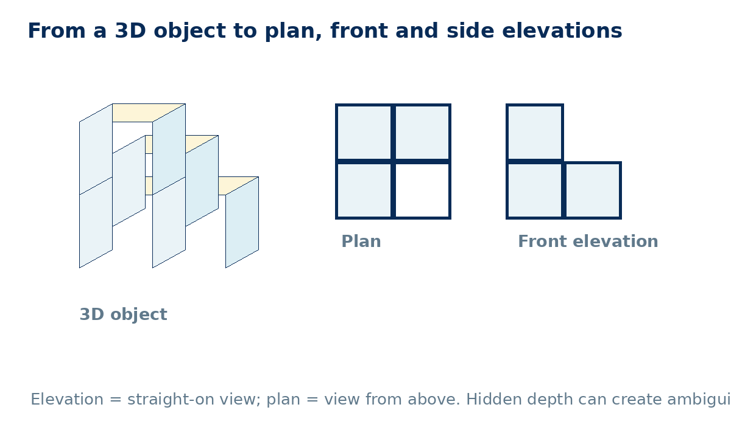

Answers and marking guidance
C1: Footprint/occupied positions when viewed from above; it may not reveal height unless encoded.
C2: Plan is from above; front elevation is a straight-on view from the named front.
P1: The plan records occupied positions, not stacked height, unless a convention such as numbers is added.
A1: Any valid solid whose projected front column heights are 2,1,1.
A2: Heights/stacking of cubes at occupied plan positions.
A3: Plan: four occupied squares; front/side each show one column 2 high and the other 1 high if the stacked corner is aligned accordingly.
E1: 6 cm at 1:100 = 6 m; 4 cm = 4 m; area = 24 m².
E2: No. Different depth arrangements can share the same maximum heights from front and side.
R1: Plan is an L of three squares; front elevation depends on named front but must show one 2-high column at the stacked position.

WWW / EBI language
- WWW: You kept each viewpoint consistent and labelled it clearly.
- WWW: Your scale conversion linked drawing length to real length correctly.
- EBI: State the viewing direction before drawing an elevation.
- EBI: Do not infer hidden depth or height that the view does not show.

Recall & Review: feedback and extension integration
Lesson L037: Plans elevations and measures
Objective: Interpret plans and elevations and connect views to three-dimensional objects.
Timing for a 60-minute lesson
0-7 Connect & Check; 7-14 Share; 14-25 Present/model; 25-44 Apply route choice/practice; 44-52 independent exam-style check; 52-60 Recall & Review, WWW/EBI and next step.
Recall & Review evidence
At the end of the lesson, solve a fresh question without prompts, explain one check, correct one error and record the next practice step.
What Went Well (WWW)
I selected the correct geometric fact, theorem, formula or transformation and used a clear diagram with appropriate labels and units.
Even Better If (EBI)
I will name the fact or theorem, show the substitution or construction step and check whether the size, direction and units of the result are reasonable.
Integrated stretch and deep challenge
Stretch: A scale plan measures 6 cm by 4 cm at 1:100. Find the real floor area in m².
Deep challenge: Two solids have identical front and side elevations. Must their plans be identical? Explain with an example.
Teacher use
Use the What Went Well (WWW) and Even Better If (EBI) prompts to write mathematics-specific feedback linked to the objective. Do not accept generic praise: identify the method, representation, reasoning or checking step that improved, then set a fresh next-step question.
Assessment evidence to inspect: Check the formative mini-test and independent workbook response against the objective. Use the teacher answers or mark guidance; group errors for reteaching. NC/C selected to purpose; label each question.

