

Knowledge organiser · Pythagoras in two dimensions
GCSE Mathematics 1MA1 · L038 · 60 minutes

Core knowledge
- Pythagoras applies only to right-angled triangles.
- a²+b²=c², where c is the hypotenuse opposite the right angle.
- Missing hypotenuse: c=√(a²+b²).
- Missing shorter side: a=√(c²−b²).
- Converse: if largest side c satisfies a²+b²=c², the triangle is right-angled.
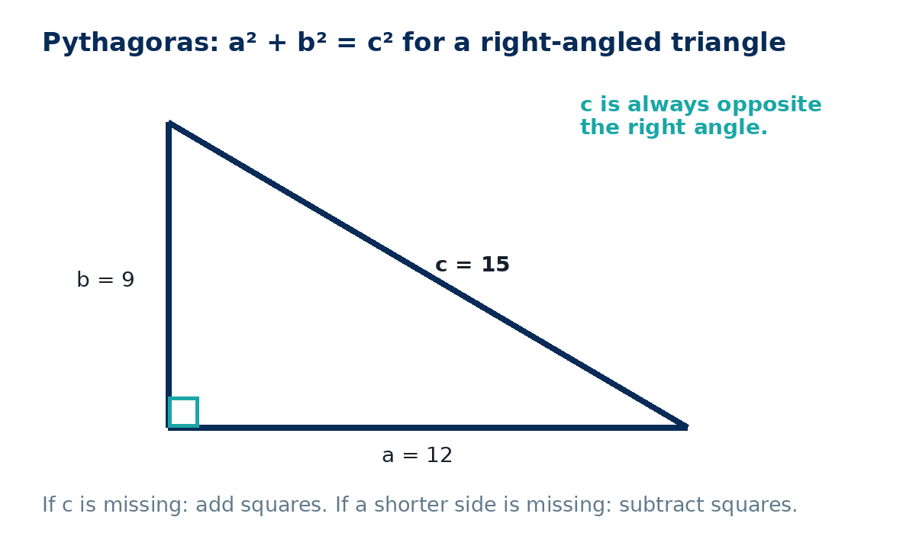

Method checklist
- Mark the right angle.
- Identify c as the hypotenuse.
- Write the equation before substituting.
- Square lengths accurately.
- Add for missing hypotenuse; subtract for missing shorter side.
- Square root at the end and check magnitude/units.

Common errors to avoid
Using the longest-looking drawn side instead of the side opposite the right angle; adding squares when a shorter side is missing; forgetting the final square root; rounding too early.

