

Pythagoras in two dimensions
GCSE Mathematics 1MA1 · L038 · 60 minutes
Objective: Use Pythagoras’ theorem to find a missing length in a right-angled triangle and justify whether a triangle is right-angled.
Calculator conditions: Core square-number examples may be non-calculator; calculator questions are labelled C. Round only when requested.
Connect & Check  5 min | Retrieve squares and square roots and identify the side opposite a right angle.

C1. Which side is the hypotenuse in a right-angled triangle? [NC] [1 marks]
________________________________________________________________________________
________________________________________________________________________________
C2. Calculate 9², 12² and √225. [NC] [3 marks]
________________________________________________________________________________
________________________________________________________________________________
________________________________________________________________________________
Share  5 min | Choose a route: Visual (draw/annotate), Method (structured calculation), or Explain (justify decisions). Compare with a partner; all routes must produce the same core evidence.

Route | Journey | Evidence
A · Visual | Annotate the triangle and square each relevant side. | Labelled diagram + equation.
B · Method | Use a structured a²+b²=c² template. | Equation + exact/rounded length.
C · Explain | Explain whether to add or subtract squares and why. | Justified method + check.

Present  12 min | Identify the hypotenuse before forming an equation. Compare missing-hypotenuse and missing-short-side cases.

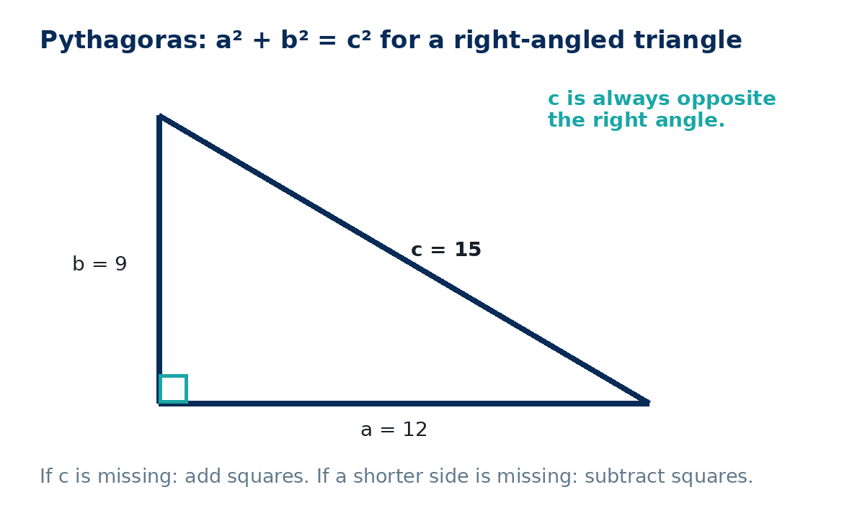
P1. A right triangle has shorter sides 9 cm and 12 cm. Find the hypotenuse. [NC] [3 marks]
________________________________________________________________________________
________________________________________________________________________________
________________________________________________________________________________
________________________________________________________________________________
Apply  25 min | Complete supported practice, then remove the scaffold and complete independent/exam-style work. Show a separate check where requested.

Supported practice
A1. Find the hypotenuse of a right triangle with legs 6 cm and 8 cm. [NC] [3 marks]
________________________________________________________________________________
________________________________________________________________________________
________________________________________________________________________________
________________________________________________________________________________
A2. A right triangle has hypotenuse 13 cm and one shorter side 5 cm. Find the other side. [NC] [4 marks]
________________________________________________________________________________
________________________________________________________________________________
________________________________________________________________________________
________________________________________________________________________________

Independent practice - scaffold removed
A3. A ladder reaches 6 m up a wall and its foot is 2.5 m from the wall. Find the ladder length. [C] [4 marks]
________________________________________________________________________________
________________________________________________________________________________
________________________________________________________________________________
________________________________________________________________________________
________________________________________________________________________________
A4. A rectangle is 9 cm by 12 cm. Find its diagonal. [NC] [3 marks]
________________________________________________________________________________
________________________________________________________________________________
________________________________________________________________________________
________________________________________________________________________________

Exam-style practice
E1. A rectangular field is 30 m by 40 m. Find the straight-line distance between opposite corners. [NC] [3 marks]
________________________________________________________________________________
________________________________________________________________________________
________________________________________________________________________________
________________________________________________________________________________
E2. A triangle has side lengths 7 cm, 24 cm and 25 cm. Show that it is right-angled. [NC] [4 marks]
________________________________________________________________________________
________________________________________________________________________________
________________________________________________________________________________
________________________________________________________________________________
________________________________________________________________________________

Extension and deep challenge
X1. A 9 cm by 12 cm rectangle is cut along a diagonal. Find the perimeter of one resulting triangle. [NC] [4 marks]
________________________________________________________________________________
________________________________________________________________________________
________________________________________________________________________________
________________________________________________________________________________
________________________________________________________________________________
X2. A triangle has sides 8 cm, 15 cm and 17 cm. Prove it is right-angled and find its area. [NC] [5 marks]
________________________________________________________________________________
________________________________________________________________________________
________________________________________________________________________________
________________________________________________________________________________
________________________________________________________________________________
Recall & Review  8 min | Complete the exit task without notes, compare with your baseline and record one WWW and one EBI.

R1. A right triangle has hypotenuse 10 cm and one shorter side 6 cm. Find the other side and show a check. [NC] [4 marks]
________________________________________________________________________________
________________________________________________________________________________
________________________________________________________________________________
________________________________________________________________________________
________________________________________________________________________________
WWW: ________________________________________________________________________
EBI: __________________________________________________________________________
Next lesson preparation: Review sine, cosine and tangent on a calculator and make sure it is in degree mode.

Recall & Review: feedback and extension integration
Lesson L038: Pythagoras in two dimensions
Objective: Use Pythagoras to find a missing length in a right-angled triangle.
Timing for a 60-minute lesson
0-7 Connect & Check; 7-14 Share; 14-25 Present/model; 25-44 Apply route choice/practice; 44-52 independent exam-style check; 52-60 Recall & Review, WWW/EBI and next step.
Recall & Review evidence
At the end of the lesson, solve a fresh question without prompts, explain one check, correct one error and record the next practice step.
What Went Well (WWW)
I selected the correct geometric fact, theorem, formula or transformation and used a clear diagram with appropriate labels and units.
Even Better If (EBI)
I will name the fact or theorem, show the substitution or construction step and check whether the size, direction and units of the result are reasonable.
Integrated stretch and deep challenge
Stretch: A rectangle is 9 cm by 12 cm. Find its diagonal and the perimeter of one of the right triangles formed by that diagonal.
Deep challenge: A triangle has sides 8, 15 and 17 cm. Prove it is right-angled and find its area.
My next-step response

