

Teacher guide · Pythagoras in two dimensions
GCSE Mathematics 1MA1 · L038 · 60 minutes
Lesson objective: Use Pythagoras’ theorem to find a missing length in a right-angled triangle and justify whether a triangle is right-angled.
60-minute flow: Connect & Check 5 · Share 5 · Present 12 · Apply 25 · Recall & Review 8 · feedback embedded.
Calculator conditions: Core square-number examples may be non-calculator; calculator questions are labelled C. Round only when requested.

Teaching sequence and misconceptions

Connect & Check
Do not accept “longest side” alone as the definition; the hypotenuse is opposite the right angle.

Share
Routes may differ, but every learner must write an equation before a calculator entry.

Present
Use c exclusively for the hypotenuse in the model. For a missing short side, rearrange by subtraction.

Apply
Check whether learners square the whole side length and take a square root only at the end.

Recall & Review
Use substitution back into a²+b²=c² as the independent check.
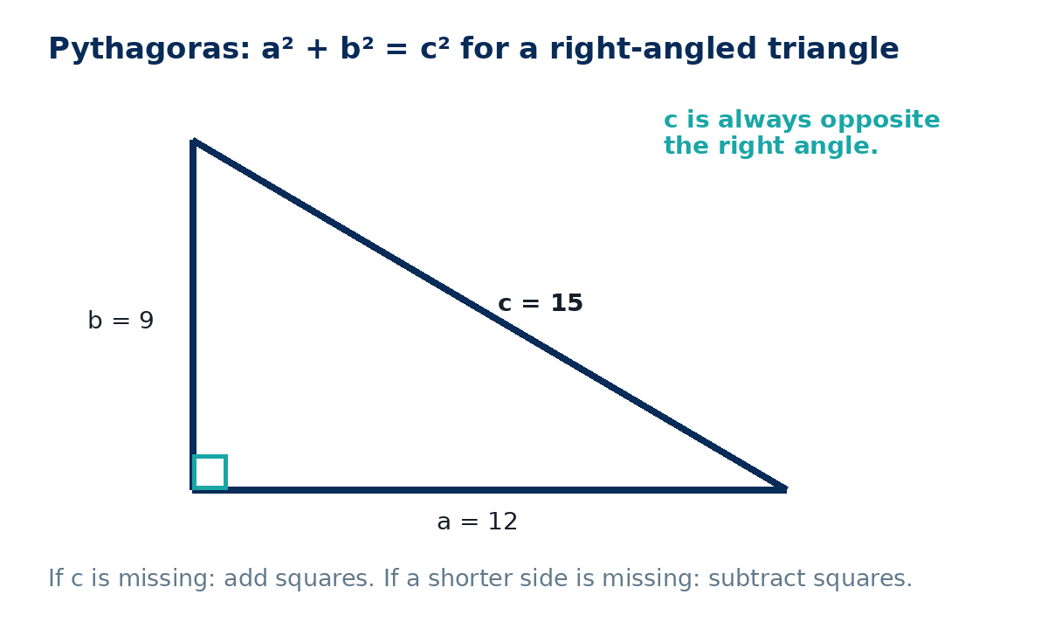

Answers and marking guidance
C1: The side opposite the right angle.
C2: 81, 144, 15.
P1: √(81+144)=15 cm.
A1: 10 cm.
A2: 12 cm.
A3: √(36+6.25)=6.5 m.
A4: 15 cm.
E1: 50 m.
E2: 7²+24²=49+576=625=25², so right-angled.
X1: 15+12+9=36 cm.
X2: 64+225=289=17²; area=½×8×15=60 cm².
R1: √(100−36)=8 cm; 6²+8²=10².

WWW / EBI language
- WWW: You identified the hypotenuse before forming the equation.
- WWW: Your check substituted the answer back into the theorem.
- EBI: If a shorter side is missing, subtract its partner square from c².
- EBI: Take the square root only after the squared-length calculation.

Recall & Review: feedback and extension integration
Lesson L038: Pythagoras in two dimensions
Objective: Use Pythagoras to find a missing length in a right-angled triangle.
Timing for a 60-minute lesson
0-7 Connect & Check; 7-14 Share; 14-25 Present/model; 25-44 Apply route choice/practice; 44-52 independent exam-style check; 52-60 Recall & Review, WWW/EBI and next step.
Recall & Review evidence
At the end of the lesson, solve a fresh question without prompts, explain one check, correct one error and record the next practice step.
What Went Well (WWW)
I selected the correct geometric fact, theorem, formula or transformation and used a clear diagram with appropriate labels and units.
Even Better If (EBI)
I will name the fact or theorem, show the substitution or construction step and check whether the size, direction and units of the result are reasonable.
Integrated stretch and deep challenge
Stretch: A rectangle is 9 cm by 12 cm. Find its diagonal and the perimeter of one of the right triangles formed by that diagonal.
Deep challenge: A triangle has sides 8, 15 and 17 cm. Prove it is right-angled and find its area.
Teacher use
Use the What Went Well (WWW) and Even Better If (EBI) prompts to write mathematics-specific feedback linked to the objective. Do not accept generic praise: identify the method, representation, reasoning or checking step that improved, then set a fresh next-step question.
Assessment evidence to inspect: Check the formative mini-test and independent workbook response against the objective. Use the teacher answers or mark guidance; group errors for reteaching. NC/C selected to purpose; label each question.

