

Knowledge organiser · Trigonometry in right triangles
GCSE Mathematics 1MA1 · L039 · 60 minutes

Core knowledge
- SOH: sinθ = opposite/hypotenuse.
- CAH: cosθ = adjacent/hypotenuse.
- TOA: tanθ = opposite/adjacent.
- Opposite and adjacent depend on the chosen acute angle; hypotenuse is always opposite the right angle.
- To find an angle, use sin⁻¹, cos⁻¹ or tan⁻¹ on the relevant ratio.
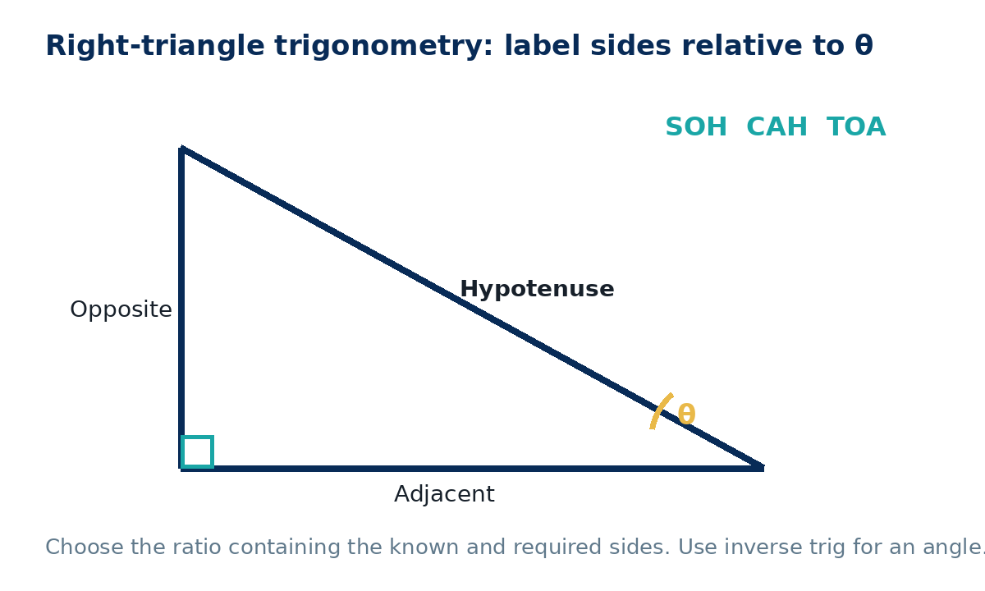

Method checklist
- Mark the right angle and given angle θ.
- Label H, then O and A relative to θ.
- Circle the known and required quantities.
- Choose the ratio containing those two sides.
- Write the equation before calculator input.
- Use inverse trig for an angle; check degree mode and round at the end.

Common errors to avoid
Labelling opposite/adjacent relative to the wrong angle; treating sin⁻¹ as a reciprocal; using radians; rearranging the ratio incorrectly; rounding intermediate values.

