

Trigonometry in right triangles
GCSE Mathematics 1MA1 · L039 · 60 minutes
Objective: Select sine, cosine or tangent to find a missing side or angle in a right-angled triangle and justify the chosen ratio.
Calculator conditions: Calculator required for trigonometric values. Check degree mode. Keep full precision until the final rounding step.
Connect & Check  5 min | Retrieve Pythagoras and side labels, then shift from “which side is longest?” to “which side is relative to the chosen angle?”.

C1. In a right triangle, which side is always the hypotenuse? [NC] [1 marks]
________________________________________________________________________________
________________________________________________________________________________
C2. Relative to an angle θ, explain how to identify the opposite and adjacent sides. [NC] [2 marks]
________________________________________________________________________________
________________________________________________________________________________
________________________________________________________________________________
Share  5 min | Choose a route: Visual (draw/annotate), Method (structured calculation), or Explain (justify decisions). Compare with a partner; all routes must produce the same core evidence.

Route | Journey | Evidence
A · Visual | Label O, A, H on the diagram and circle known/required values. | Labelled triangle + ratio.
B · Method | Use SOHCAHTOA as a selection table. | Chosen ratio + equation.
C · Explain | State why one ratio contains exactly the needed sides. | Justification + solution.

Present  12 min | Label sides relative to the given angle. Model calculator degree mode and inverse-function notation.

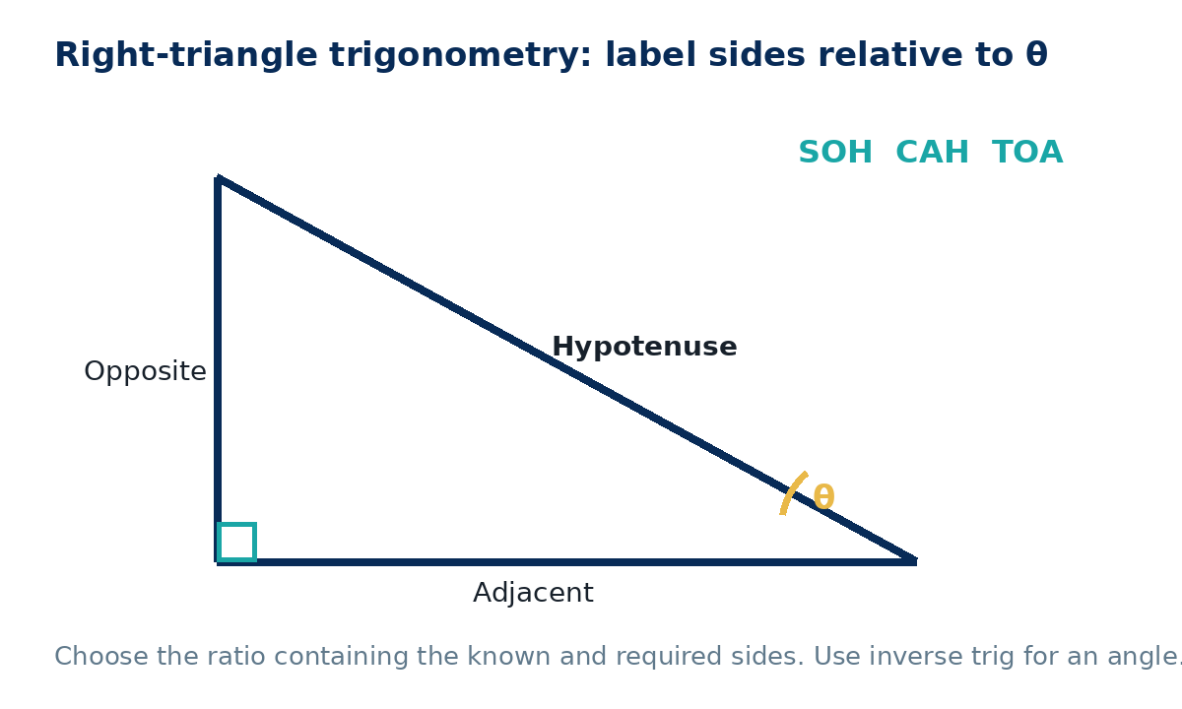
P1. A right triangle has adjacent side 8 cm and angle 35°. Find the opposite side to 2 d.p. [C] [3 marks]
________________________________________________________________________________
________________________________________________________________________________
________________________________________________________________________________
________________________________________________________________________________
Apply  25 min | Complete supported practice, then remove the scaffold and complete independent/exam-style work. Show a separate check where requested.

Supported practice
A1. Angle θ=30°, hypotenuse=10 cm. Find the opposite side. [C] [3 marks]
________________________________________________________________________________
________________________________________________________________________________
________________________________________________________________________________
________________________________________________________________________________
A2. Opposite=7 cm, hypotenuse=10 cm. Find θ to 1 d.p. [C] [4 marks]
________________________________________________________________________________
________________________________________________________________________________
________________________________________________________________________________
________________________________________________________________________________

Independent practice - scaffold removed
A3. Adjacent=12 cm, θ=28°. Find the hypotenuse to 1 d.p. [C] [4 marks]
________________________________________________________________________________
________________________________________________________________________________
________________________________________________________________________________
________________________________________________________________________________
________________________________________________________________________________
A4. Opposite=9 cm, adjacent=14 cm. Find θ to 1 d.p. [C] [4 marks]
________________________________________________________________________________
________________________________________________________________________________
________________________________________________________________________________
________________________________________________________________________________
________________________________________________________________________________

Exam-style practice
E1. A ladder 5.5 m long makes an angle of 68° with the ground. How high up the wall does it reach? Give 2 d.p. [C] [4 marks]
________________________________________________________________________________
________________________________________________________________________________
________________________________________________________________________________
________________________________________________________________________________
________________________________________________________________________________
E2. From a point 20 m from the base of a vertical tower, the angle of elevation to the top is 32°. Find the tower height to 1 d.p. [C] [4 marks]
________________________________________________________________________________
________________________________________________________________________________
________________________________________________________________________________
________________________________________________________________________________
________________________________________________________________________________

Extension and deep challenge
X1. Two right triangles both have angle 30° but hypotenuses 10 cm and 25 cm. Compare their opposite sides. [C] [4 marks]
________________________________________________________________________________
________________________________________________________________________________
________________________________________________________________________________
________________________________________________________________________________
________________________________________________________________________________
X2. A right triangle has area 30 cm² and one acute angle 40°. Find one possible pair of perpendicular side lengths. [C] [6 marks]
________________________________________________________________________________
________________________________________________________________________________
________________________________________________________________________________
________________________________________________________________________________
________________________________________________________________________________
________________________________________________________________________________
Recall & Review  8 min | Complete the exit task without notes, compare with your baseline and record one WWW and one EBI.

R1. A right triangle has opposite side 6 cm and adjacent side 11 cm relative to θ. Find θ to 1 d.p. and state the ratio used. [C] [4 marks]
________________________________________________________________________________
________________________________________________________________________________
________________________________________________________________________________
________________________________________________________________________________
________________________________________________________________________________
WWW: ________________________________________________________________________
EBI: __________________________________________________________________________
Next lesson preparation: Review cumulative number, algebra and geometry topics ready for the next checkpoint lesson.

Recall & Review: feedback and extension integration
Lesson L039: Trigonometry in right triangles
Objective: Select sine, cosine or tangent to find a right-triangle side or angle.
Timing for a 60-minute lesson
0-7 Connect & Check; 7-14 Share; 14-25 Present/model; 25-44 Apply route choice/practice; 44-52 independent exam-style check; 52-60 Recall & Review, WWW/EBI and next step.
Recall & Review evidence
At the end of the lesson, solve a fresh question without prompts, explain one check, correct one error and record the next practice step.
What Went Well (WWW)
I selected the correct geometric fact, theorem, formula or transformation and used a clear diagram with appropriate labels and units.
Even Better If (EBI)
I will name the fact or theorem, show the substitution or construction step and check whether the size, direction and units of the result are reasonable.
Integrated stretch and deep challenge
Stretch: A right triangle has adjacent side 8 cm and an angle of 35°. Find the opposite side to 2 d.p.
Deep challenge: Two right triangles share angle 30° but have hypotenuses 10 cm and 25 cm. Compare their opposite sides.
My next-step response

