

Teacher guide · Trigonometry in right triangles
GCSE Mathematics 1MA1 · L039 · 60 minutes
Lesson objective: Select sine, cosine or tangent to find a missing side or angle in a right-angled triangle and justify the chosen ratio.
60-minute flow: Connect & Check 5 · Share 5 · Present 12 · Apply 25 · Recall & Review 8 · feedback embedded.
Calculator conditions: Calculator required for trigonometric values. Check degree mode. Keep full precision until the final rounding step.

Teaching sequence and misconceptions

Connect & Check
Side labels O/A depend on the chosen acute angle; H does not.

Share
Learners may choose visual labelling or a ratio table, but must justify the selected ratio.

Present
Check calculators are in degree mode. Model sin⁻¹ as inverse sine, not 1/sin.

Apply
Remove SOHCAHTOA scaffold by A3. Require equation before calculator input.

Recall & Review
A correct answer without a stated ratio is incomplete evidence against the full objective.
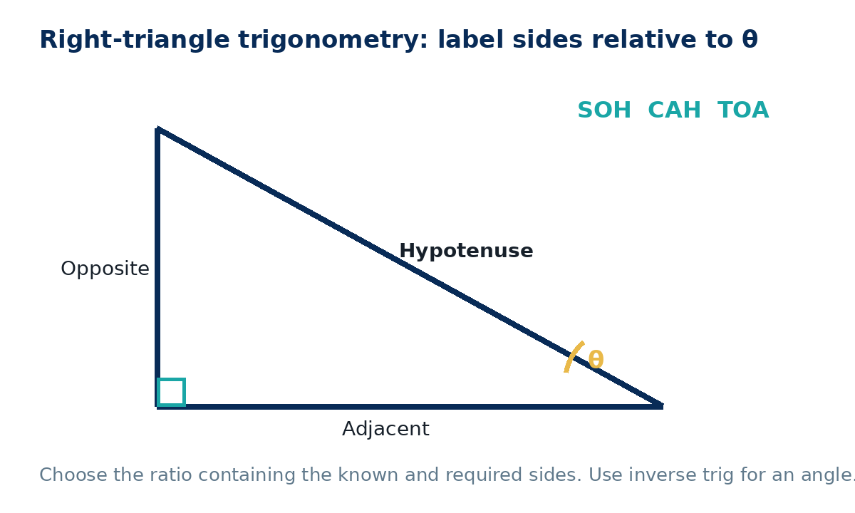

Answers and marking guidance
C1: The side opposite the right angle.
C2: Opposite is across from θ; adjacent touches θ but is not the hypotenuse.
P1: tan35=o/8, so o=8tan35≈5.60 cm.
A1: sin30=o/10, so o=5 cm.
A2: sinθ=0.7, θ=sin⁻¹(0.7)≈44.4°.
A3: cos28=12/h, h=12/cos28≈13.6 cm.
A4: tanθ=9/14, θ≈32.7°.
E1: 5.5sin68≈5.10 m.
E2: 20tan32≈12.5 m.
X1: 5 cm and 12.5 cm; second is 2.5 times first, matching scale factor.
R1: tanθ=6/11; θ≈28.6°.

WWW / EBI language
- WWW: You labelled sides relative to the chosen angle before selecting a ratio.
- WWW: You used inverse trigonometry correctly to find an angle.
- EBI: Write the trig equation before calculator input.
- EBI: Check degree mode and keep full precision until the final rounding step.

Recall & Review: feedback and extension integration
Lesson L039: Trigonometry in right triangles
Objective: Select sine, cosine or tangent to find a right-triangle side or angle.
Timing for a 60-minute lesson
0-7 Connect & Check; 7-14 Share; 14-25 Present/model; 25-44 Apply route choice/practice; 44-52 independent exam-style check; 52-60 Recall & Review, WWW/EBI and next step.
Recall & Review evidence
At the end of the lesson, solve a fresh question without prompts, explain one check, correct one error and record the next practice step.
What Went Well (WWW)
I selected the correct geometric fact, theorem, formula or transformation and used a clear diagram with appropriate labels and units.
Even Better If (EBI)
I will name the fact or theorem, show the substitution or construction step and check whether the size, direction and units of the result are reasonable.
Integrated stretch and deep challenge
Stretch: A right triangle has adjacent side 8 cm and an angle of 35°. Find the opposite side to 2 d.p.
Deep challenge: Two right triangles share angle 30° but have hypotenuses 10 cm and 25 cm. Compare their opposite sides.
Teacher use
Use the What Went Well (WWW) and Even Better If (EBI) prompts to write mathematics-specific feedback linked to the objective. Do not accept generic praise: identify the method, representation, reasoning or checking step that improved, then set a fresh next-step question.
Assessment evidence to inspect: Check the formative mini-test and independent workbook response against the objective. Use the teacher answers or mark guidance; group errors for reteaching. NC/C selected to purpose; label each question.

