
Reach for the Star | GCSE Mathematics 1MA1 | L040

Knowledge organiser: Cumulative checkpoint 2 and feedback
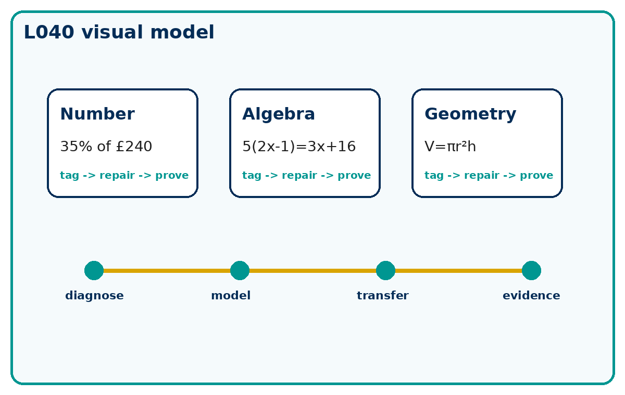

Core knowledge
- Use the repair cycle: identify the first incorrect decision, replace it with a correct method, then test it on a matched question.
- A repaired answer is not secure until it works without the prompt.
- Calculator condition: Non-calculator first attempt. Calculator permitted only for explicitly labelled check questions.

Method checklist
- Name the known information.
- Choose a route and justify it.
- Show the calculation clearly.
- Check against the context or graph.
- State units or interpretation where needed.

Key terms
Term | Meaning
number | A key idea for this lesson.
algebra | A key idea for this lesson.
geometry | A key idea for this lesson.
repair | A corrected method shown on a fresh question.

