
Reach for the Star | GCSE Mathematics 1MA1 | L040

Learner workbook: Cumulative checkpoint 2 and feedback
Objective: Apply and explain earlier number, algebra and geometry independently. Diagnose method errors and complete a targeted repair.
Calculator condition: Non-calculator first attempt. Calculator permitted only for explicitly labelled check questions.
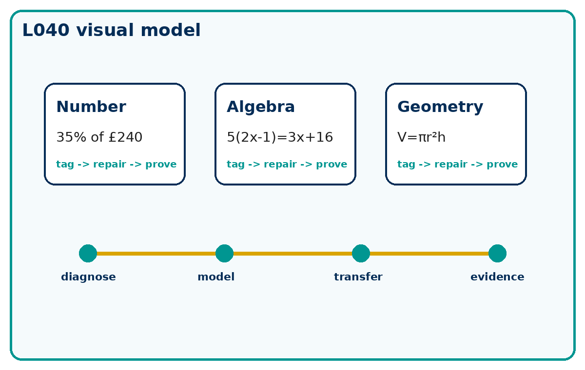

Connect & Check
- Without notes, answer three retrieval questions: one number, one algebra and one geometry.
- Tag any uncertainty as method, operation, unit or diagram.

Choose your route
A - Visual  Sketch, annotate or use the diagram. | B - Method  Use a table, calculation chain or formula. | C - Explain  Write sentences explaining why the method works.

Share
- Compare the first decision you made in each question.
- Decide whether an error would come from recall, method choice or execution.

Present: modelled method
- Use the repair cycle: identify the first incorrect decision, replace it with a correct method, then test it on a matched question.
- A repaired answer is not secure until it works without the prompt.

Apply: supported to independent practice
Number: Find 35% of £240 and explain the reference whole.
Working: ______________________________________________________________
Check: _________________________________________________________________
Algebra: Solve 5(2x - 1)=3x+16 and check.
Working: ______________________________________________________________
Check: _________________________________________________________________
Geometry: A cylinder has radius 4 cm and height 5 cm. Find volume exactly.
Working: ______________________________________________________________
Check: _________________________________________________________________

Stretch and deep challenge
- Stretch: A cylinder has radius 4 cm and height 5 cm. Find its volume exactly, then state the units of surface area.
- Deep challenge: A learner uses 8² + 15² = 17 in a Pythagoras check. Identify and repair the error.

Recall & Review
- Solve one fresh mixed question without notes.
- Write the specific next-practice target, not a vague topic name.
WWW: ______________________________________ EBI: ______________________________________

Recall & Review: feedback and extension integration
Lesson L040: Cumulative checkpoint 2 and feedback
Objective: Apply and explain earlier number, algebra and geometry independently.
Timing for a 60-minute lesson
0-7 Connect & Check; 7-14 Share; 14-25 Present/model; 25-44 Apply route choice/practice; 44-52 independent exam-style check; 52-60 Recall & Review, WWW/EBI and next step.
Recall & Review evidence
At the end of the lesson, solve a fresh question without prompts, explain one check, correct one error and record the next practice step.
What Went Well (WWW)
I used my working and assessment evidence to identify the exact mathematical step that was secure and the specific misconception that needs attention.
Even Better If (EBI)
I will correct one precise step, explain why the correction works and complete a fresh delayed question without the original scaffold.
Integrated stretch and deep challenge
Stretch: A cylinder has radius 4 cm and height 5 cm. Find its volume exactly, then state the units of surface area.
Deep challenge: A learner uses 8²+15²=17 in a Pythagoras check. Identify and repair the error.
My next-step response

