
Reach for the Star | GCSE Mathematics 1MA1 | L041

Knowledge organiser: Coordinates, gradient and intercept
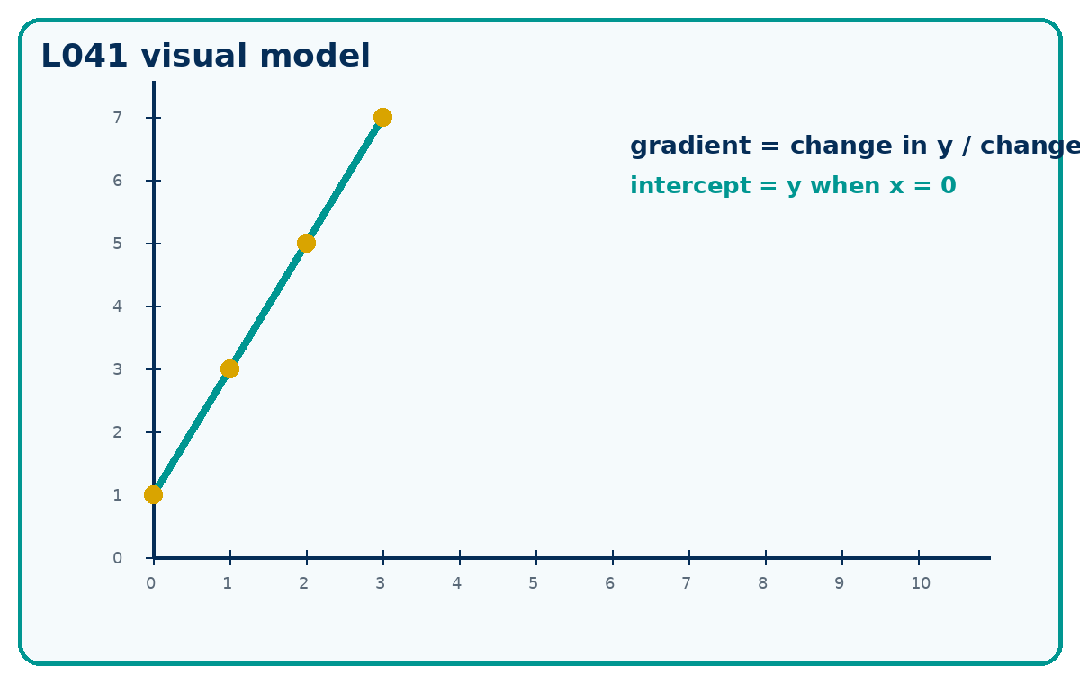

Core knowledge
- Gradient is change in y divided by change in x.
- The vertical intercept is where the line crosses the y-axis, so x = 0.
- Calculator condition: Non-calculator core. Calculator not required.

Method checklist
- Name the known information.
- Choose a route and justify it.
- Show the calculation clearly.
- Check against the context or graph.
- State units or interpretation where needed.

Key terms
Term | Meaning
coordinates | A pair (x, y) locating a point.
gradient | Change in y divided by change in x.
intercept | Where a line crosses an axis.
graph | A key idea for this lesson.

