
Reach for the Star | GCSE Mathematics 1MA1 | L041

Learner workbook: Coordinates, gradient and intercept
Objective: Plot coordinates and interpret gradient and vertical intercept from tables, graphs and equations.
Calculator condition: Non-calculator core. Calculator not required.
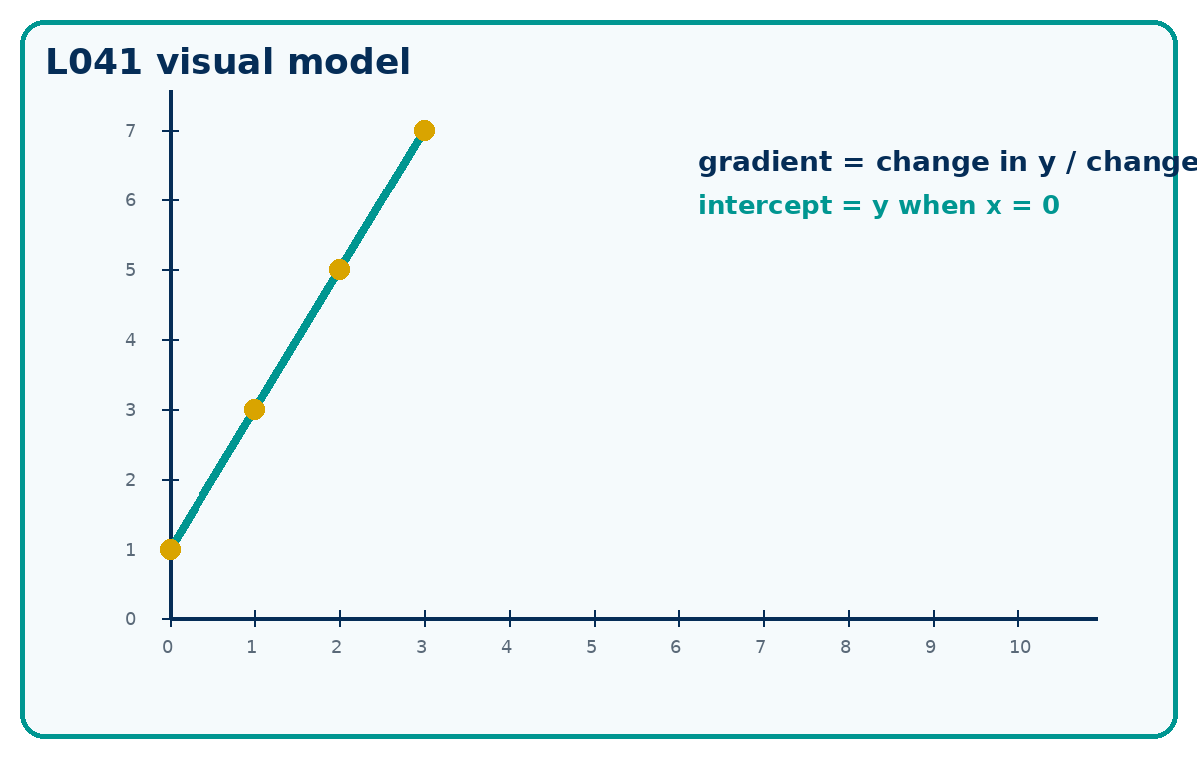

Connect & Check
- Plot (0, 2), (1, 4), (2, 6) and describe the pattern.
- Retrieve: what does one horizontal step do to the height?

Choose your route
A - Visual  Sketch, annotate or use the diagram. | B - Method  Use a table, calculation chain or formula. | C - Explain  Write sentences explaining why the method works.

Share
- Compare two routes: coordinate table first or graph first.
- Explain how you can tell whether a gradient is positive, negative or zero.

Present: modelled method
- Gradient is change in y divided by change in x.
- The vertical intercept is where the line crosses the y-axis, so x = 0.

Apply: supported to independent practice
Plotting: Plot (0,1), (1,3), (2,5), (3,7).
Working: ______________________________________________________________
Check: _________________________________________________________________
Gradient: Find the gradient of the line through (2,1) and (6,9).
Working: ______________________________________________________________
Check: _________________________________________________________________
Intercept: For y = 3x - 4, state the gradient and y-intercept.
Working: ______________________________________________________________
Check: _________________________________________________________________

Stretch and deep challenge
- Stretch: A line passes through (-3, 4) and (3, -2). Find gradient and y-intercept.
- Deep challenge: Can two distinct parallel lines have different gradients? Explain using y = mx + c.

Recall & Review
- Given two fresh points, find the gradient and y-intercept without prompts.
- Correct one plotting or scale error.
WWW: ______________________________________ EBI: ______________________________________

Recall & Review: feedback and extension integration
Lesson L041: Coordinates gradient and intercept
Objective: Plot coordinates and interpret gradient and vertical intercept.
Timing for a 60-minute lesson
0-7 Connect & Check; 7-14 Share; 14-25 Present/model; 25-44 Apply route choice/practice; 44-52 independent exam-style check; 52-60 Recall & Review, WWW/EBI and next step.
Recall & Review evidence
At the end of the lesson, solve a fresh question without prompts, explain one check, correct one error and record the next practice step.
What Went Well (WWW)
I read or constructed the graph accurately, used the scale and axes correctly and linked the relevant gradient, intercept, shape or trend to my conclusion.
Even Better If (EBI)
I will label units and scale clearly, show the calculation or graphical evidence I used and check that the interpretation fits the context.
Integrated stretch and deep challenge
Stretch: A line passes through (−3, 4) and (3, −2). Find gradient and y-intercept.
Deep challenge: Can two distinct parallel lines have different gradients? Explain using y=mx+c.
My next-step response

