
Reach for the Star | GCSE Mathematics 1MA1 | L042

Knowledge organiser: Straight line equations
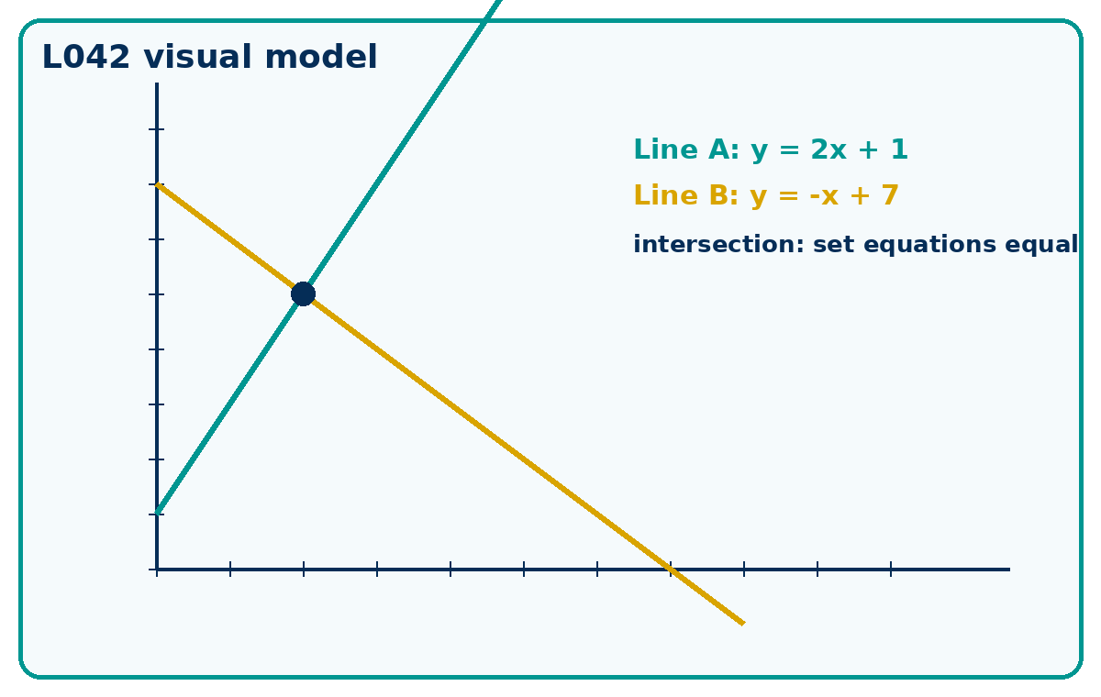

Core knowledge
- Use y = mx + c. Substitute a point to test it.
- For intersections, set the two y-values equal, solve for x, then find y.
- Calculator condition: Non-calculator core. Calculator optional for checking plotted intersections only.

Method checklist
- Name the known information.
- Choose a route and justify it.
- Show the calculation clearly.
- Check against the context or graph.
- State units or interpretation where needed.

Key terms
Term | Meaning
y=mx+c | A key idea for this lesson.
parallel | Lines with the same gradient and different intercepts.
intersection | The point where two lines meet.
substitution | A key idea for this lesson.

