
Reach for the Star | GCSE Mathematics 1MA1 | L042

Learner workbook: Straight line equations
Objective: Form and use straight-line equations, check whether points lie on a line and locate intersections.
Calculator condition: Non-calculator core. Calculator optional for checking plotted intersections only.
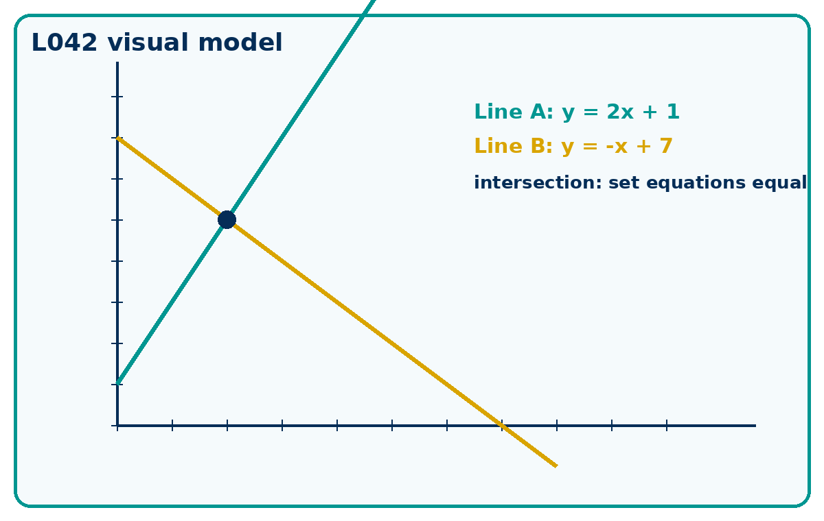

Connect & Check
- Retrieve gradient and intercept from y = 2x + 1 and y = -x + 4.
- Predict where two lines might meet before calculating.

Choose your route
A - Visual  Sketch, annotate or use the diagram. | B - Method  Use a table, calculation chain or formula. | C - Explain  Write sentences explaining why the method works.

Share
- Compare table, graph and equation routes.
- Explain why equal gradients create parallel lines when intercepts differ.

Present: modelled method
- Use y = mx + c. Substitute a point to test it.
- For intersections, set the two y-values equal, solve for x, then find y.

Apply: supported to independent practice
Equation: Find the equation of a line with gradient 2 and intercept -3.
Working: ______________________________________________________________
Check: _________________________________________________________________
Point check: Does (4,5) lie on y = 2x - 3?
Working: ______________________________________________________________
Check: _________________________________________________________________
Parallel: Are y = 4x + 1 and y = 4x - 6 parallel? Explain.
Working: ______________________________________________________________
Check: _________________________________________________________________

Stretch and deep challenge
- Stretch: Find the equation of the line through (2, -1) and (6, 7).
- Deep challenge: The lines y = 3x - 4 and 6x - 2y = 8 are claimed to intersect. Test the claim.

Recall & Review
- Check a point against a fresh line equation.
- Decide if two lines intersect, are parallel or are the same line.
WWW: ______________________________________ EBI: ______________________________________

Recall & Review: feedback and extension integration
Lesson L042: Straight line equations
Objective: Form and use straight-line equations and locate intersections.
Timing for a 60-minute lesson
0-7 Connect & Check; 7-14 Share; 14-25 Present/model; 25-44 Apply route choice/practice; 44-52 independent exam-style check; 52-60 Recall & Review, WWW/EBI and next step.
Recall & Review evidence
At the end of the lesson, solve a fresh question without prompts, explain one check, correct one error and record the next practice step.
What Went Well (WWW)
I represented the algebraic structure accurately, kept each transformation valid and checked the result by substitution, graph or equivalent reasoning.
Even Better If (EBI)
I will show the missing inverse operation or algebraic step, keep signs and brackets accurate and test the result in the original relationship.
Integrated stretch and deep challenge
Stretch: Find the equation of the line through (2,−1) and (6,7).
Deep challenge: The lines y=3x−4 and 6x−2y=8 are claimed to intersect. Test the claim.
My next-step response

