
Reach for the Star | GCSE Mathematics 1MA1 | L043

Knowledge organiser: Distance time and speed graphs
Objective: Interpret distance–time and speed–time graphs in context.
Calculator condition: Calculator allowed where labelled; non-calculator reasoning remains required.
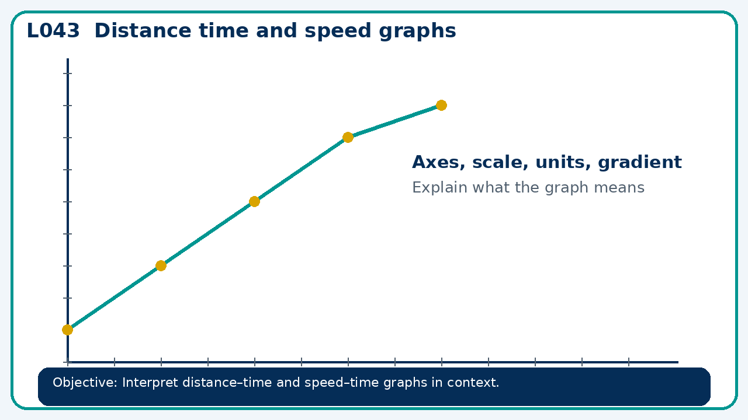

Core knowledge
- Distinguish height from gradient; connect area under a speed graph to distance

Method checklist
- Identify what the question is asking.
- Choose the relevant representation or method.
- Show working clearly and label units.
- Check the answer against the original context.
- Write one sentence explaining why the answer is reasonable.

Common error to avoid
- A distance-time graph has a downward segment. Explain what the vertical axis must represent if the graph is valid.

