
Reach for the Star | GCSE Mathematics 1MA1 | L043

Learner workbook: Distance time and speed graphs
Objective: Interpret distance–time and speed–time graphs in context.
Calculator condition: Calculator allowed where labelled; non-calculator reasoning remains required.
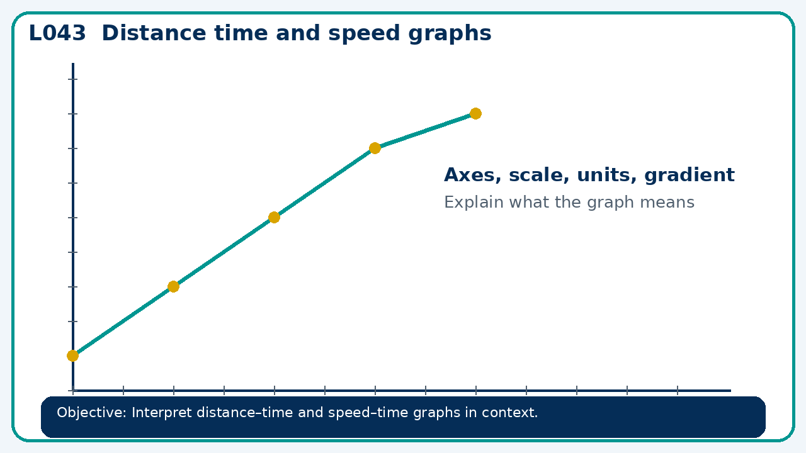

Connect & Check
- State the objective and timeline. Retrieve straight line equations or a prerequisite. Diagnose a common error before modelling.
- Write one starting question you want answered today.

Choose your route
Route A: Visual  Use a diagram, graph, table or annotation first. | Route B: Method  Use a worked method, formula or calculation chain first. | Route C: Explain  Start with words: what is known, what is changing, and why.

Share
- Pairs compare methods or predict a result for distance time and speed graphs. Ask for a reason, not only an answer.

Present
- Distinguish height from gradient; connect area under a speed graph to distance

Apply: supported to independent
Recall: Retrieve the key fact or method needed for distance time and speed graphs.
Working: ______________________________________________________________
Check/explanation: ____________________________________________________
Core practice: A runner covers 400 m in 80 s, rests for 20 s, then covers 200 m in 40 s. Find average speed for the whole journey.
Working: ______________________________________________________________
Check/explanation: ____________________________________________________
Reasoning: A distance-time graph has a downward segment. Explain what the vertical axis must represent if the graph is valid.
Working: ______________________________________________________________
Check/explanation: ____________________________________________________
Exam-style: A graph is drawn for a real context. Interpret the gradient, intercept or area as appropriate. State units and justify your answer.
Working: ______________________________________________________________
Check/explanation: ____________________________________________________

Recall & Review
- Revisit the objective. Learners solve a fresh item without prompts, explain a check, correct one error and record the next practice.
WWW: ________________________________ EBI: ________________________________

Recall & Review: feedback and extension integration
Lesson L043: Distance time and speed graphs
Objective: Interpret distance–time and speed–time graphs in context.
Timing for a 60-minute lesson
0-7 Connect & Check; 7-14 Share; 14-25 Present/model; 25-44 Apply route choice/practice; 44-52 independent exam-style check; 52-60 Recall & Review, WWW/EBI and next step.
Recall & Review evidence
At the end of the lesson, solve a fresh question without prompts, explain one check, correct one error and record the next practice step.
What Went Well (WWW)
I read or constructed the graph accurately, used the scale and axes correctly and linked the relevant gradient, intercept, shape or trend to my conclusion.
Even Better If (EBI)
I will label units and scale clearly, show the calculation or graphical evidence I used and check that the interpretation fits the context.
Integrated stretch and deep challenge
Stretch: A runner covers 400 m in 80 s, rests for 20 s, then covers 200 m in 40 s. Find average speed for the whole journey.
Deep challenge: A distance-time graph has a downward segment. Explain what the vertical axis must represent if the graph is valid.
My next-step response

