
Reach for the Star | GCSE Mathematics 1MA1 | L044

Knowledge organiser: Graph problems and repair
Objective: Choose graphical methods and repair errors in interpreting axes and gradients.
Calculator condition: Calculator allowed where labelled; non-calculator reasoning remains required.
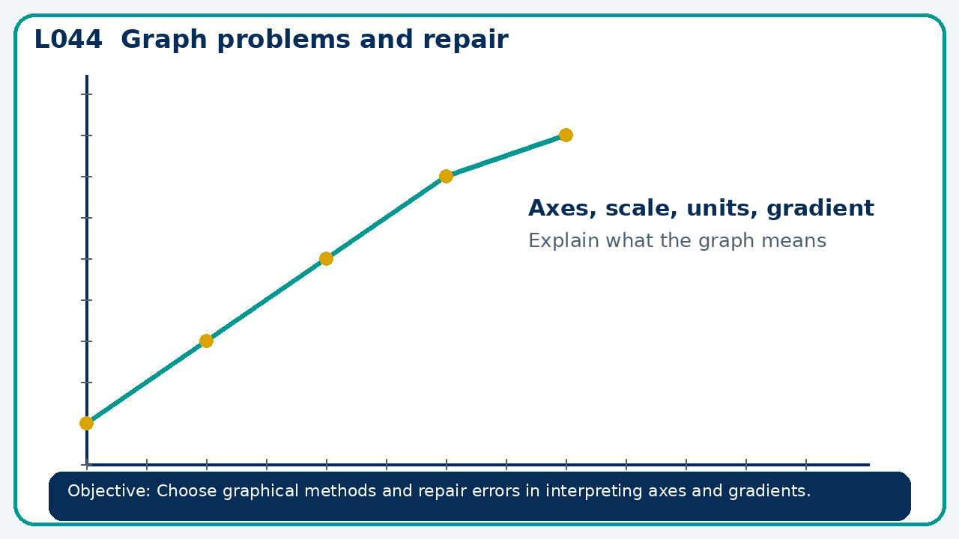

Core knowledge
- Compare two incorrect graphs; reteach scale or gradient from diagnostic evidence

Method checklist
- Identify what the question is asking.
- Choose the relevant representation or method.
- Show working clearly and label units.
- Check the answer against the original context.
- Write one sentence explaining why the answer is reasonable.

Common error to avoid
- Explain why the mean of 30 and 60 is not the overall speed for equal distances.

