
Reach for the Star | GCSE Mathematics 1MA1 | L045

Knowledge organiser: Sampling and data quality
Objective: Recognise populations, samples, bias and limits of conclusions.
Calculator condition: Non-calculator core; calculator optional only for checking where labelled.
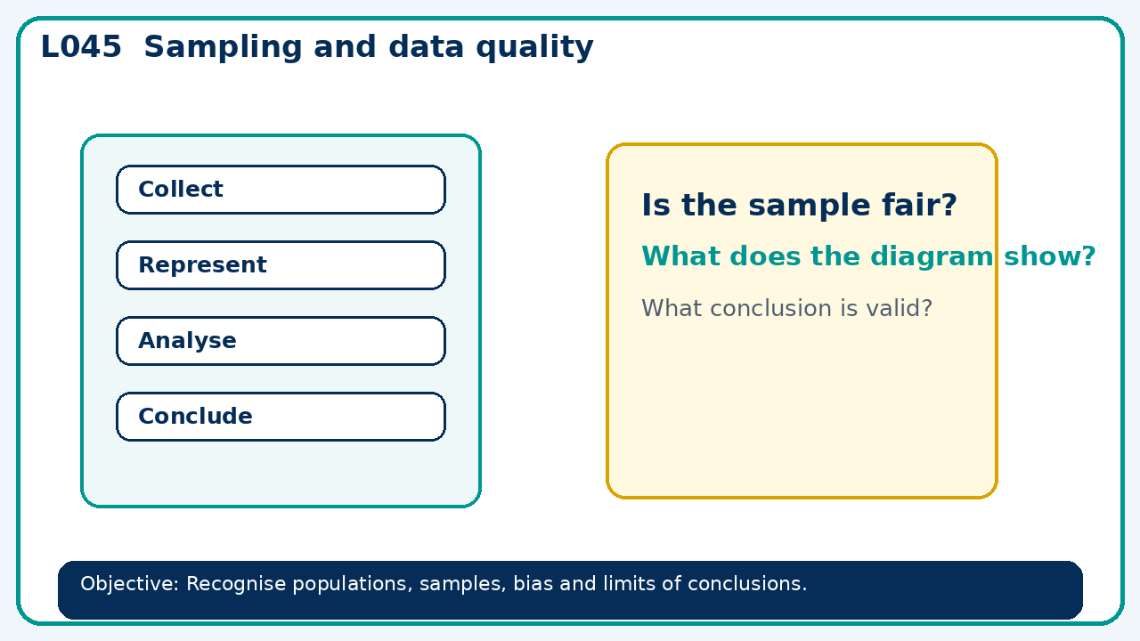

Core knowledge
- Compare survey designs and identify which groups may be excluded

Method checklist
- Identify what the question is asking.
- Choose the relevant representation or method.
- Show working clearly and label units.
- Check the answer against the original context.
- Write one sentence explaining why the answer is reasonable.

Common error to avoid
- A survey about canteen food is sent only to the school's sports team. Give two distinct sources of bias and improve selection.

