
Reach for the Star | GCSE Mathematics 1MA1 | L046

Knowledge organiser: Tables charts and time series
Objective: Represent and interpret categorical data, grouped data and time series.
Calculator condition: Non-calculator core; calculator optional only for checking where labelled.
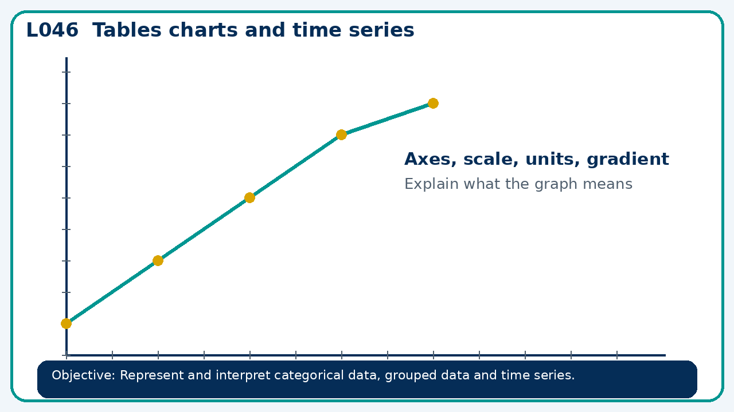

Core knowledge
- Choose a suitable chart; check labels, scale and misleading presentation

Method checklist
- Identify what the question is asking.
- Choose the relevant representation or method.
- Show working clearly and label units.
- Check the answer against the original context.
- Write one sentence explaining why the answer is reasonable.

Common error to avoid
- A time-series graph starts its vertical axis at 90 instead of 0. Does this make the data wrong? Explain the risk.

