
Reach for the Star | GCSE Mathematics 1MA1 | L046

Learner workbook: Tables charts and time series
Objective: Represent and interpret categorical data, grouped data and time series.
Calculator condition: Non-calculator core; calculator optional only for checking where labelled.
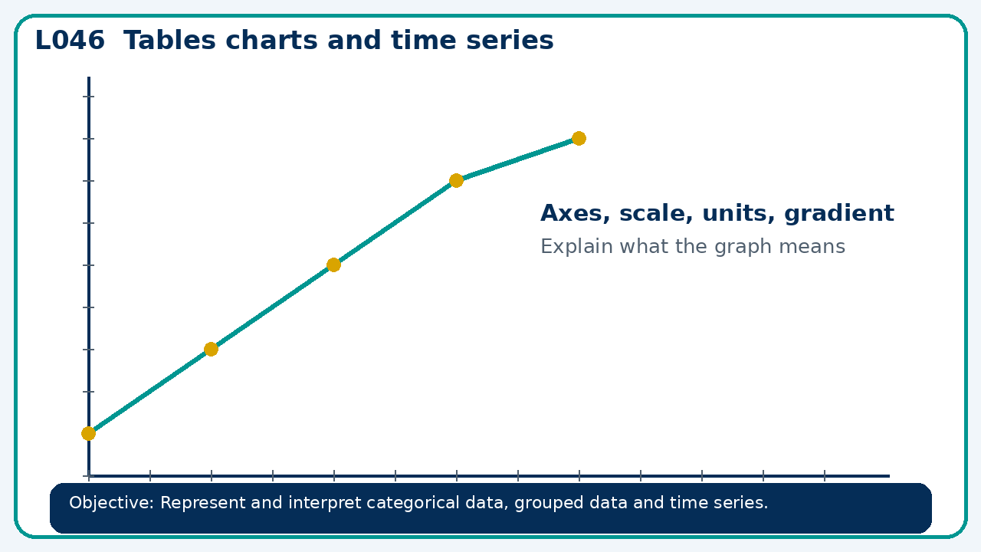

Connect & Check
- State the objective and timeline. Retrieve sampling and data quality or a prerequisite. Diagnose a common error before modelling.
- Write one starting question you want answered today.

Choose your route
Route A: Visual  Use a diagram, graph, table or annotation first. | Route B: Method  Use a worked method, formula or calculation chain first. | Route C: Explain  Start with words: what is known, what is changing, and why.

Share
- Pairs compare methods or predict a result for tables charts and time series. Ask for a reason, not only an answer.

Present
- Choose a suitable chart; check labels, scale and misleading presentation

Apply: supported to independent
Recall: Retrieve the key fact or method needed for tables charts and time series.
Working: ______________________________________________________________
Check/explanation: ____________________________________________________
Core practice: A pie chart represents 72 people. A sector angle is 135°. Find its frequency.
Working: ______________________________________________________________
Check/explanation: ____________________________________________________
Reasoning: A time-series graph starts its vertical axis at 90 instead of 0. Does this make the data wrong? Explain the risk.
Working: ______________________________________________________________
Check/explanation: ____________________________________________________
Exam-style: Solve an exam-style problem involving tables charts and time series. Show working, include a check and interpret your answer.
Working: ______________________________________________________________
Check/explanation: ____________________________________________________

Recall & Review
- Revisit the objective. Learners solve a fresh item without prompts, explain a check, correct one error and record the next practice.
WWW: ________________________________ EBI: ________________________________

Recall & Review: feedback and extension integration
Lesson L046: Tables charts and time series
Objective: Represent and interpret categorical data, grouped data and time series.
Timing for a 60-minute lesson
0-7 Connect & Check; 7-14 Share; 14-25 Present/model; 25-44 Apply route choice/practice; 44-52 independent exam-style check; 52-60 Recall & Review, WWW/EBI and next step.
Recall & Review evidence
At the end of the lesson, solve a fresh question without prompts, explain one check, correct one error and record the next practice step.
What Went Well (WWW)
I selected an appropriate statistic or representation and supported my comparison or interpretation with specific evidence from the data.
Even Better If (EBI)
I will quote the relevant values or features, compare like with like and explain what the evidence shows without making an unsupported claim.
Integrated stretch and deep challenge
Stretch: A pie chart represents 72 people. A sector angle is 135°. Find its frequency.
Deep challenge: A time-series graph starts its vertical axis at 90 instead of 0. Does this make the data wrong? Explain the risk.
My next-step response

