
Reach for the Star | GCSE Mathematics 1MA1 | L047

Knowledge organiser: Averages and spread
Objective: Calculate and interpret averages and range, including grouped estimates.
Calculator condition: Non-calculator core; calculator optional only for checking where labelled.
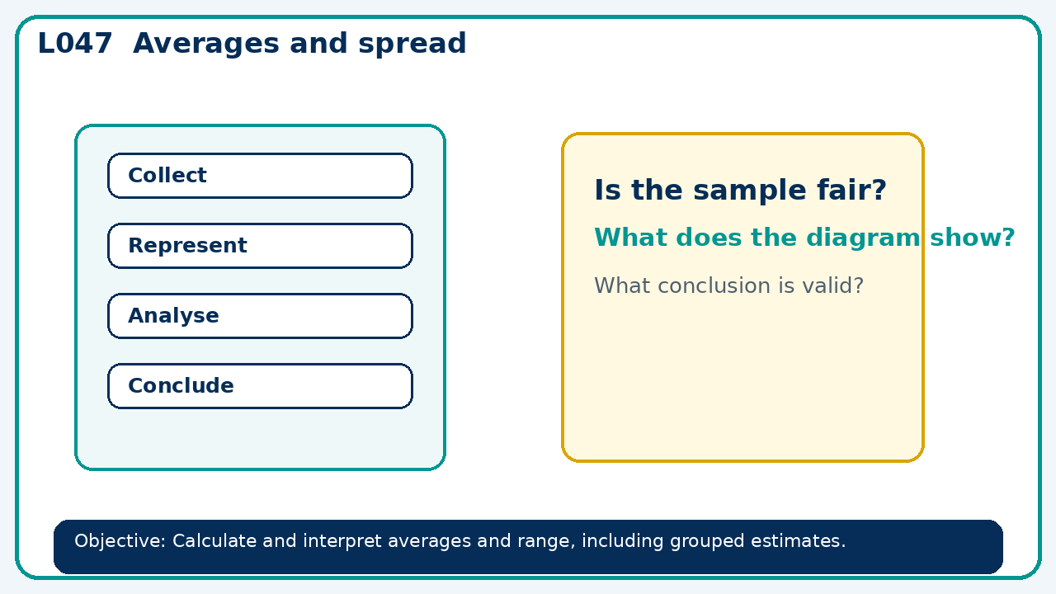

Core knowledge
- Contrast exact data with grouped estimates; explore the effect of an outlier

Method checklist
- Identify what the question is asking.
- Choose the relevant representation or method.
- Show working clearly and label units.
- Check the answer against the original context.
- Write one sentence explaining why the answer is reasonable.

Common error to avoid
- A data set has mean 10. One new value of 100 is added. Must the median increase?

