
Reach for the Star | GCSE Mathematics 1MA1 | L047

Learner workbook: Averages and spread
Objective: Calculate and interpret averages and range, including grouped estimates.
Calculator condition: Non-calculator core; calculator optional only for checking where labelled.
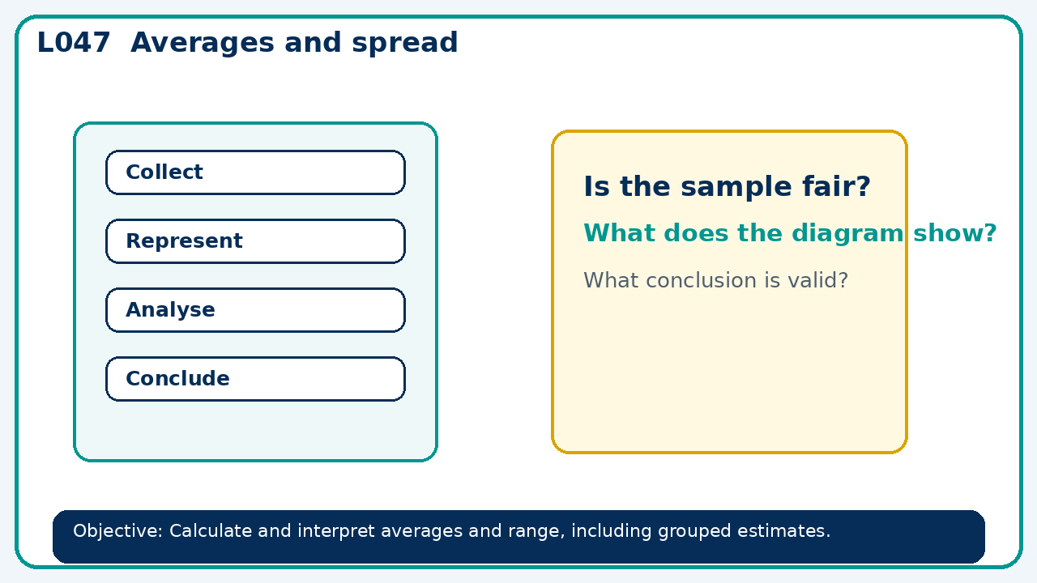

Connect & Check
- State the objective and timeline. Retrieve tables charts and time series or a prerequisite. Diagnose a common error before modelling.
- Write one starting question you want answered today.

Choose your route
Route A: Visual  Use a diagram, graph, table or annotation first. | Route B: Method  Use a worked method, formula or calculation chain first. | Route C: Explain  Start with words: what is known, what is changing, and why.

Share
- Pairs compare methods or predict a result for averages and spread. Ask for a reason, not only an answer.

Present
- Contrast exact data with grouped estimates; explore the effect of an outlier

Apply: supported to independent
Recall: Retrieve the key fact or method needed for averages and spread.
Working: ______________________________________________________________
Check/explanation: ____________________________________________________
Core practice: Five numbers have mean 12. Four are 8, 11, 13 and 15. Find the fifth and the range.
Working: ______________________________________________________________
Check/explanation: ____________________________________________________
Reasoning: A data set has mean 10. One new value of 100 is added. Must the median increase?
Working: ______________________________________________________________
Check/explanation: ____________________________________________________
Exam-style: Solve an exam-style problem involving averages and spread. Show working, include a check and interpret your answer.
Working: ______________________________________________________________
Check/explanation: ____________________________________________________

Recall & Review
- Revisit the objective. Learners solve a fresh item without prompts, explain a check, correct one error and record the next practice.
WWW: ________________________________ EBI: ________________________________

Recall & Review: feedback and extension integration
Lesson L047: Averages and spread
Objective: Calculate and interpret averages and range, including grouped estimates.
Timing for a 60-minute lesson
0-7 Connect & Check; 7-14 Share; 14-25 Present/model; 25-44 Apply route choice/practice; 44-52 independent exam-style check; 52-60 Recall & Review, WWW/EBI and next step.
Recall & Review evidence
At the end of the lesson, solve a fresh question without prompts, explain one check, correct one error and record the next practice step.
What Went Well (WWW)
I selected an appropriate statistic or representation and supported my comparison or interpretation with specific evidence from the data.
Even Better If (EBI)
I will quote the relevant values or features, compare like with like and explain what the evidence shows without making an unsupported claim.
Integrated stretch and deep challenge
Stretch: Five numbers have mean 12. Four are 8, 11, 13 and 15. Find the fifth and the range.
Deep challenge: A data set has mean 10. One new value of 100 is added. Must the median increase?
My next-step response

