
Reach for the Star | GCSE Mathematics 1MA1 | L048

Knowledge organiser: Statistical comparisons
Objective: Compare distributions using context, a typical value and spread.
Calculator condition: Non-calculator core; calculator optional only for checking where labelled.
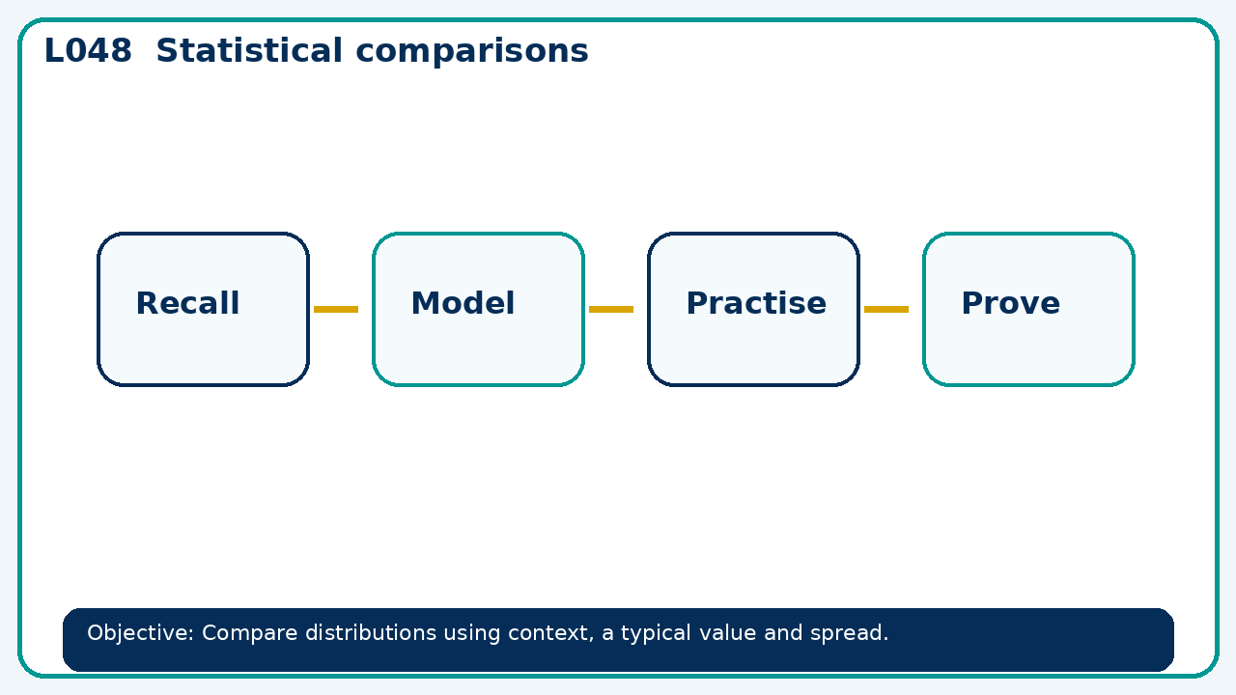

Core knowledge
- Model a comparison supported by two statistics; critique an unsupported claim

Method checklist
- Identify what the question is asking.
- Choose the relevant representation or method.
- Show working clearly and label units.
- Check the answer against the original context.
- Write one sentence explaining why the answer is reasonable.

Common error to avoid
- Two groups share mean 20. One has range 2 and the other 30. What can and cannot be concluded?

