
Reach for the Star | GCSE Mathematics 1MA1 | L048

Learner workbook: Statistical comparisons
Objective: Compare distributions using context, a typical value and spread.
Calculator condition: Non-calculator core; calculator optional only for checking where labelled.
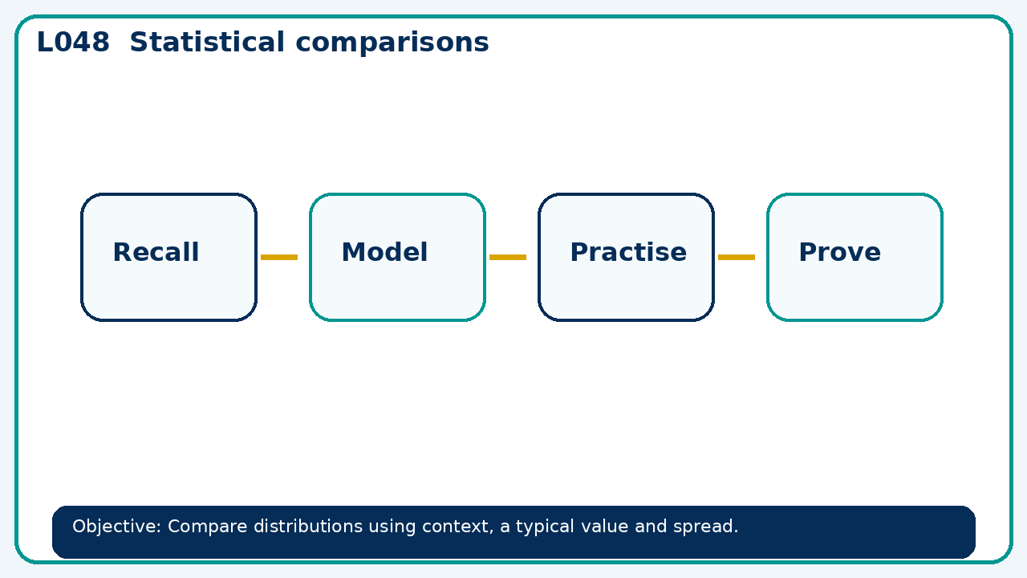

Connect & Check
- State the objective and timeline. Retrieve averages and spread or a prerequisite. Diagnose a common error before modelling.
- Write one starting question you want answered today.

Choose your route
Route A: Visual  Use a diagram, graph, table or annotation first. | Route B: Method  Use a worked method, formula or calculation chain first. | Route C: Explain  Start with words: what is known, what is changing, and why.

Share
- Pairs compare methods or predict a result for statistical comparisons. Ask for a reason, not only an answer.

Present
- Model a comparison supported by two statistics; critique an unsupported claim

Apply: supported to independent
Recall: Retrieve the key fact or method needed for statistical comparisons.
Working: ______________________________________________________________
Check/explanation: ____________________________________________________
Core practice: Class A has median 14 and IQR 3; class B median 16 and IQR 9. Compare typical score and consistency.
Working: ______________________________________________________________
Check/explanation: ____________________________________________________
Reasoning: Two groups share mean 20. One has range 2 and the other 30. What can and cannot be concluded?
Working: ______________________________________________________________
Check/explanation: ____________________________________________________
Exam-style: Solve an exam-style problem involving statistical comparisons. Show working, include a check and interpret your answer.
Working: ______________________________________________________________
Check/explanation: ____________________________________________________

Recall & Review
- Revisit the objective. Learners solve a fresh item without prompts, explain a check, correct one error and record the next practice.
WWW: ________________________________ EBI: ________________________________

Recall & Review: feedback and extension integration
Lesson L048: Statistical comparisons
Objective: Compare distributions using context, a typical value and spread.
Timing for a 60-minute lesson
0-7 Connect & Check; 7-14 Share; 14-25 Present/model; 25-44 Apply route choice/practice; 44-52 independent exam-style check; 52-60 Recall & Review, WWW/EBI and next step.
Recall & Review evidence
At the end of the lesson, solve a fresh question without prompts, explain one check, correct one error and record the next practice step.
What Went Well (WWW)
I selected an appropriate statistic or representation and supported my comparison or interpretation with specific evidence from the data.
Even Better If (EBI)
I will quote the relevant values or features, compare like with like and explain what the evidence shows without making an unsupported claim.
Integrated stretch and deep challenge
Stretch: Class A has median 14 and IQR 3; class B median 16 and IQR 9. Compare typical score and consistency.
Deep challenge: Two groups share mean 20. One has range 2 and the other 30. What can and cannot be concluded?
My next-step response

