
Reach for the Star | GCSE Mathematics 1MA1 | L049

Knowledge organiser: Probability and expected frequency
Objective: Use the probability scale and calculate expected frequency.
Calculator condition: Non-calculator core; calculator optional only for checking where labelled.
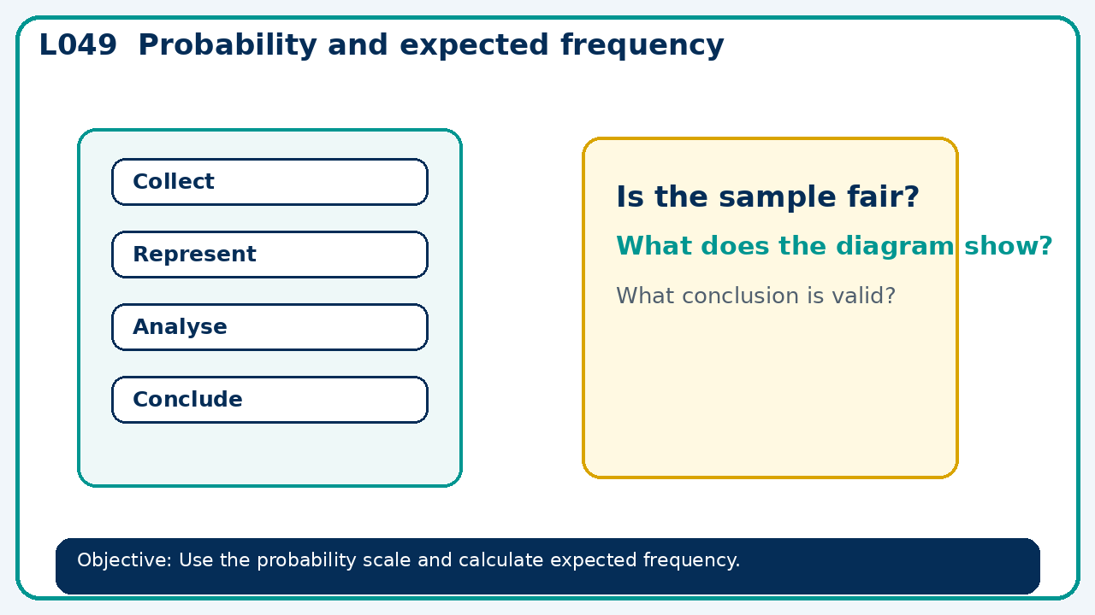

Core knowledge
- Connect equally likely outcomes with long-run expectation; distinguish expectation from certainty

Method checklist
- Identify what the question is asking.
- Choose the relevant representation or method.
- Show working clearly and label units.
- Check the answer against the original context.
- Write one sentence explaining why the answer is reasonable.

Common error to avoid
- Why is an expected frequency of 26 not a guarantee of exactly 26 successes?

