
Reach for the Star | GCSE Mathematics 1MA1 | L050

Knowledge organiser: Sample spaces and systematic lists
Objective: List outcomes systematically and calculate probabilities from sample spaces.
Calculator condition: Non-calculator core; calculator optional only for checking where labelled.
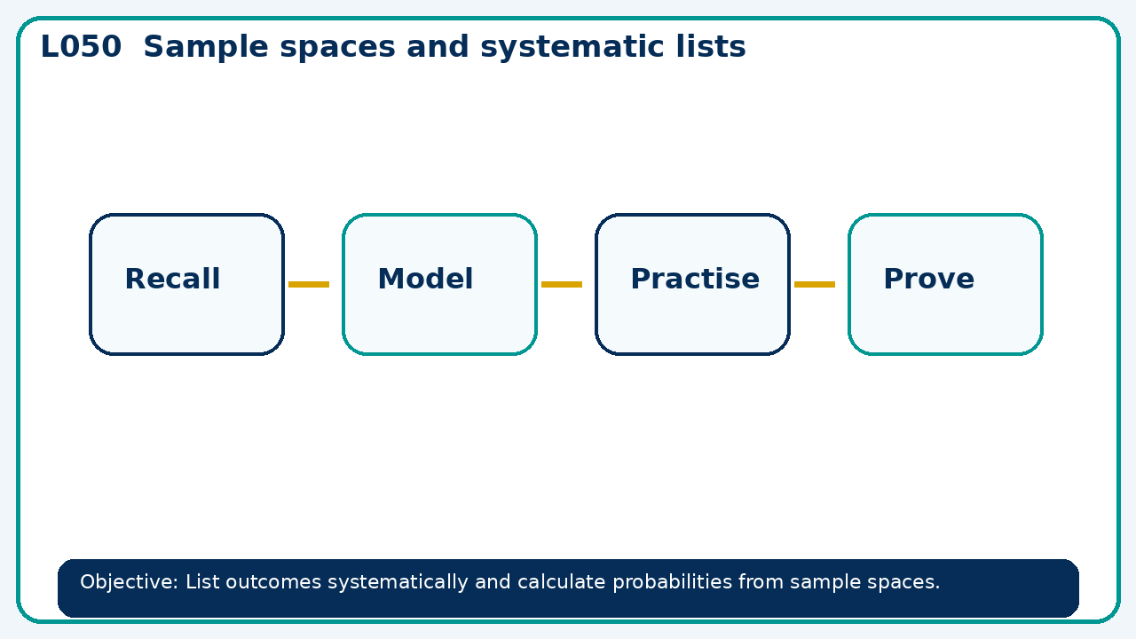

Core knowledge
- Construct a table or tree; check that outcomes are exhaustive and equally likely

Method checklist
- Identify what the question is asking.
- Choose the relevant representation or method.
- Show working clearly and label units.
- Check the answer against the original context.
- Write one sentence explaining why the answer is reasonable.

Common error to avoid
- A learner lists (1,3) and (3,1) as one outcome when two distinct dice are rolled. Explain the effect.

