
Reach for the Star | GCSE Mathematics 1MA1 | L051

Knowledge organiser: Venn diagrams and set notation
Objective: Interpret Venn diagrams and use set notation in probability.
Calculator condition: Non-calculator core; calculator optional only for checking where labelled.
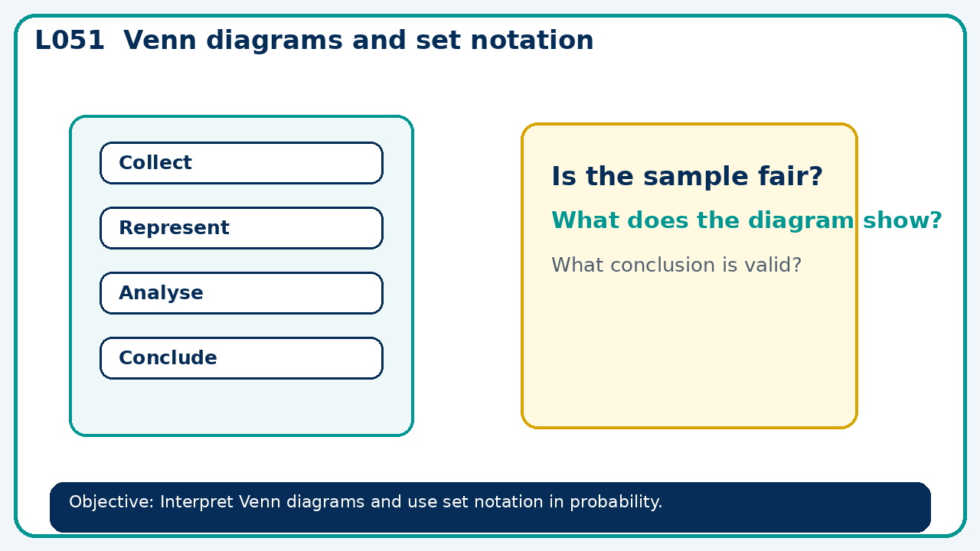

Core knowledge
- Place overlaps first and account for outcomes outside the sets

Method checklist
- Identify what the question is asking.
- Choose the relevant representation or method.
- Show working clearly and label units.
- Check the answer against the original context.
- Write one sentence explaining why the answer is reasonable.

Common error to avoid
- If P(A)=0.6, P(B)=0.5 and P(A∩B)=0.2, find P(neither).

