
Reach for the Star | GCSE Mathematics 1MA1 | L051

Learner workbook: Venn diagrams and set notation
Objective: Interpret Venn diagrams and use set notation in probability.
Calculator condition: Non-calculator core; calculator optional only for checking where labelled.
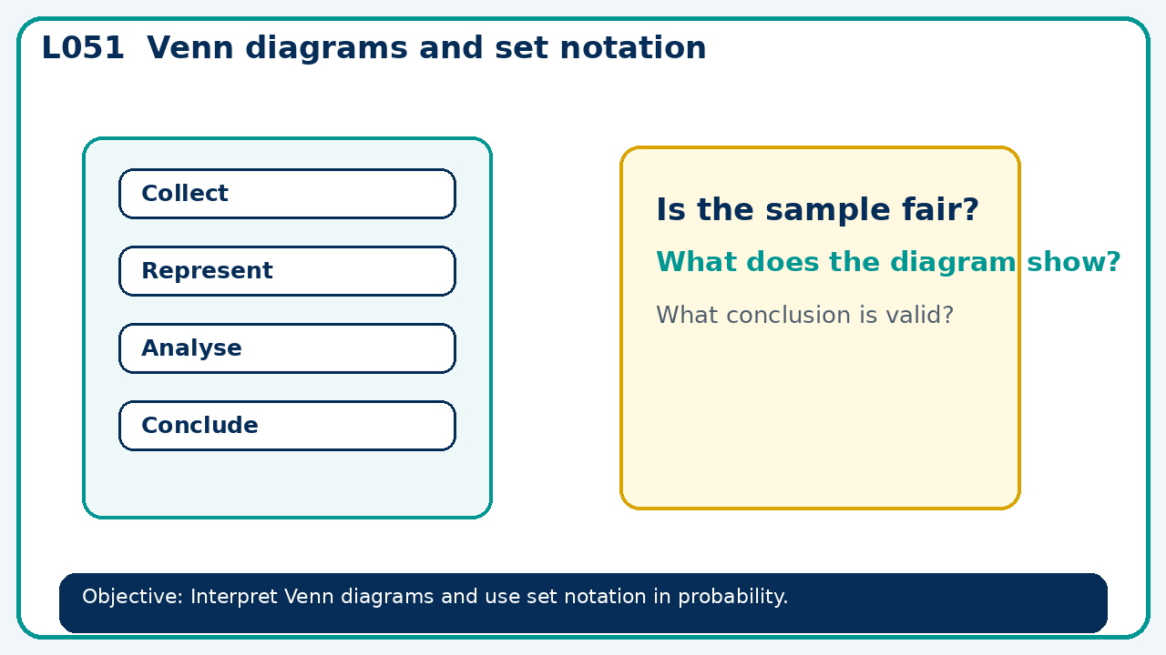

Connect & Check
- State the objective and timeline. Retrieve sample spaces and systematic lists or a prerequisite. Diagnose a common error before modelling.
- Write one starting question you want answered today.

Choose your route
Route A: Visual  Use a diagram, graph, table or annotation first. | Route B: Method  Use a worked method, formula or calculation chain first. | Route C: Explain  Start with words: what is known, what is changing, and why.

Share
- Pairs compare methods or predict a result for venn diagrams and set notation. Ask for a reason, not only an answer.

Present
- Place overlaps first and account for outcomes outside the sets

Apply: supported to independent
Recall: Retrieve the key fact or method needed for venn diagrams and set notation.
Working: ______________________________________________________________
Check/explanation: ____________________________________________________
Core practice: Of 50 learners, 24 study art, 22 music and 8 both. Find how many study exactly one.
Working: ______________________________________________________________
Check/explanation: ____________________________________________________
Reasoning: If P(A)=0.6, P(B)=0.5 and P(A∩B)=0.2, find P(neither).
Working: ______________________________________________________________
Check/explanation: ____________________________________________________
Exam-style: Solve an exam-style problem involving venn diagrams and set notation. Show working, include a check and interpret your answer.
Working: ______________________________________________________________
Check/explanation: ____________________________________________________

Recall & Review
- Revisit the objective. Learners solve a fresh item without prompts, explain a check, correct one error and record the next practice.
WWW: ________________________________ EBI: ________________________________

Recall & Review: feedback and extension integration
Lesson L051: Venn diagrams and set notation
Objective: Interpret Venn diagrams and use set notation in probability.
Timing for a 60-minute lesson
0-7 Connect & Check; 7-14 Share; 14-25 Present/model; 25-44 Apply route choice/practice; 44-52 independent exam-style check; 52-60 Recall & Review, WWW/EBI and next step.
Recall & Review evidence
At the end of the lesson, solve a fresh question without prompts, explain one check, correct one error and record the next practice step.
What Went Well (WWW)
I represented the outcomes systematically, used the correct probability rule and checked that the probabilities or frequencies were consistent.
Even Better If (EBI)
I will show the sample space, branch or set reasoning explicitly, state any dependence or condition and check totals before giving the final probability.
Integrated stretch and deep challenge
Stretch: Of 50 learners, 24 study art, 22 music and 8 both. Find how many study exactly one.
Deep challenge: If P(A)=0.6, P(B)=0.5 and P(A∩B)=0.2, find P(neither).
My next-step response

