
Reach for the Star | GCSE Mathematics 1MA1 | L052

Knowledge organiser: Cumulative checkpoint 3 and feedback
Objective: Apply and explain earlier graphs, statistics, probability and number independently.
Calculator condition: Non-calculator core; calculator optional only for checking where labelled.
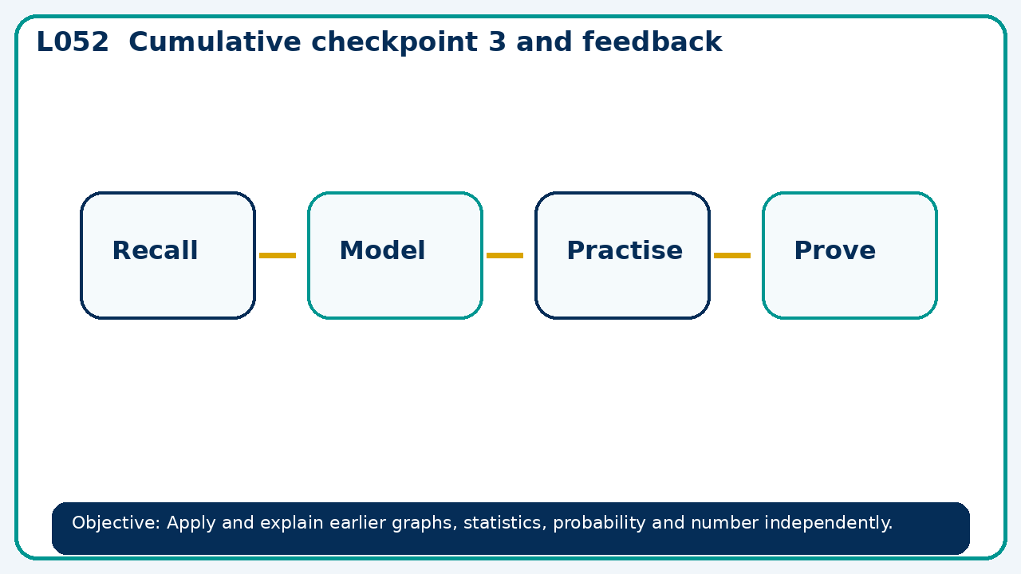

Core knowledge
- Use cumulative assessment and error analysis to choose reteaching

Method checklist
- Identify what the question is asking.
- Choose the relevant representation or method.
- Show working clearly and label units.
- Check the answer against the original context.
- Write one sentence explaining why the answer is reasonable.

Common error to avoid
- A student says a probability of 1.2 is possible because it came from a frequency table. Diagnose the error.

