
Reach for the Star | GCSE Mathematics 1MA1 | L053

Knowledge organiser: Powers roots and index laws
Objective: Use powers, roots and index laws with valid conditions.
Calculator condition: Non-calculator core; calculator optional only for checking where labelled.
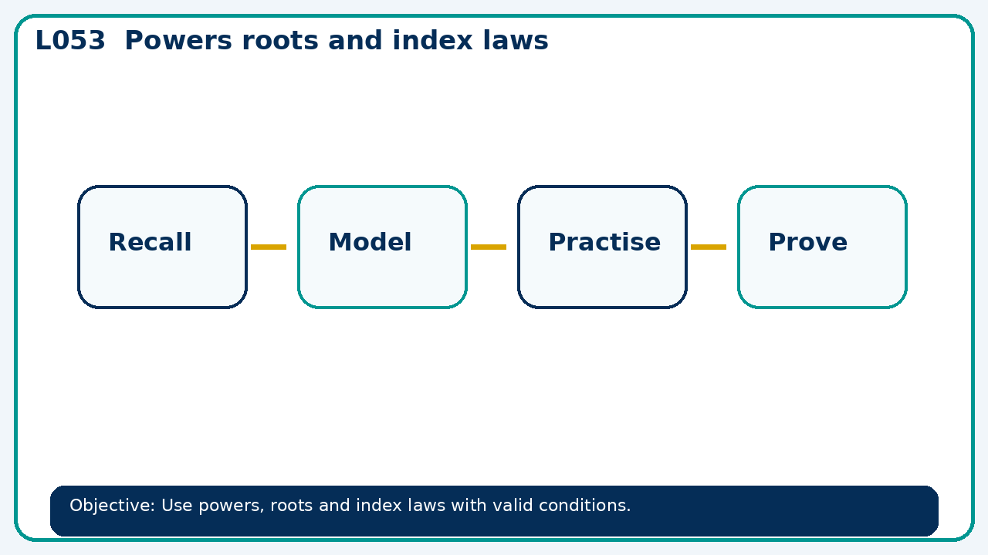

Core knowledge
- Compare repeated multiplication with laws; test a false rule using a counterexample

Method checklist
- Identify what the question is asking.
- Choose the relevant representation or method.
- Show working clearly and label units.
- Check the answer against the original context.
- Write one sentence explaining why the answer is reasonable.

Common error to avoid
- Is x⁵+x³=x⁸? Show why or give a counterexample.

