
Reach for the Star | GCSE Mathematics 1MA1 | L053

Learner workbook: Powers roots and index laws
Objective: Use powers, roots and index laws with valid conditions.
Calculator condition: Non-calculator core; calculator optional only for checking where labelled.
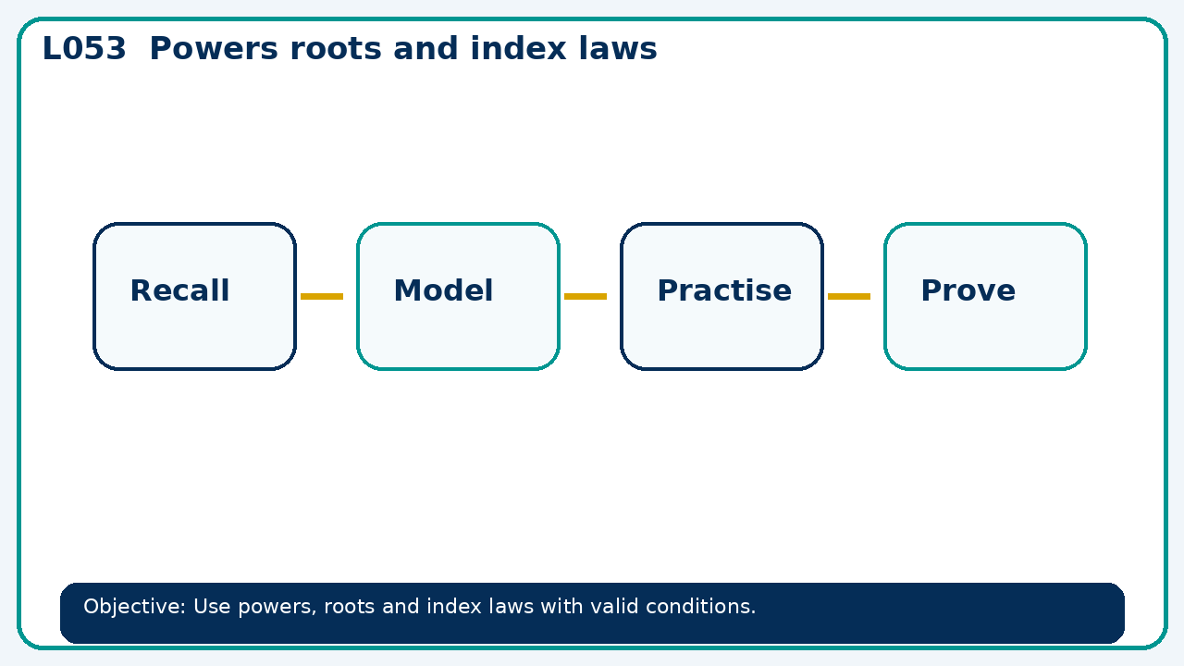

Connect & Check
- State the objective and timeline. Retrieve cumulative checkpoint 3 and feedback or a prerequisite. Diagnose a common error before modelling.
- Write one starting question you want answered today.

Choose your route
Route A: Visual  Use a diagram, graph, table or annotation first. | Route B: Method  Use a worked method, formula or calculation chain first. | Route C: Explain  Start with words: what is known, what is changing, and why.

Share
- Pairs compare methods or predict a result for powers roots and index laws. Ask for a reason, not only an answer.

Present
- Compare repeated multiplication with laws; test a false rule using a counterexample

Apply: supported to independent
Recall: Retrieve the key fact or method needed for powers roots and index laws.
Working: ______________________________________________________________
Check/explanation: ____________________________________________________
Core practice: Simplify (3x²y³)(2x⁴y) and state any assumptions.
Working: ______________________________________________________________
Check/explanation: ____________________________________________________
Reasoning: Is x⁵+x³=x⁸? Show why or give a counterexample.
Working: ______________________________________________________________
Check/explanation: ____________________________________________________
Exam-style: Solve an exam-style problem involving powers roots and index laws. Show working, include a check and interpret your answer.
Working: ______________________________________________________________
Check/explanation: ____________________________________________________

Recall & Review
- Revisit the objective. Learners solve a fresh item without prompts, explain a check, correct one error and record the next practice.
WWW: ________________________________ EBI: ________________________________

Recall & Review: feedback and extension integration
Lesson L053: Powers roots and index laws
Objective: Use powers, roots and index laws with valid conditions.
Timing for a 60-minute lesson
0-7 Connect & Check; 7-14 Share; 14-25 Present/model; 25-44 Apply route choice/practice; 44-52 independent exam-style check; 52-60 Recall & Review, WWW/EBI and next step.
Recall & Review evidence
At the end of the lesson, solve a fresh question without prompts, explain one check, correct one error and record the next practice step.
What Went Well (WWW)
I selected an efficient numerical method, showed the key steps clearly and checked the sign, size or accuracy of my answer.
Even Better If (EBI)
I will make the place-value, sign or operation decision explicit and use estimation or an inverse calculation to check a fresh question.
Integrated stretch and deep challenge
Stretch: Simplify (3x²y³)(2x⁴y) and state any assumptions.
Deep challenge: Is x⁵+x³=x⁸? Show why or give a counterexample.
My next-step response

