
Reach for the Star | GCSE Mathematics 1MA1 | L054

Knowledge organiser: Standard form
Objective: Convert to and from standard form and perform calculations.
Calculator condition: Calculator allowed where labelled; non-calculator reasoning remains required.
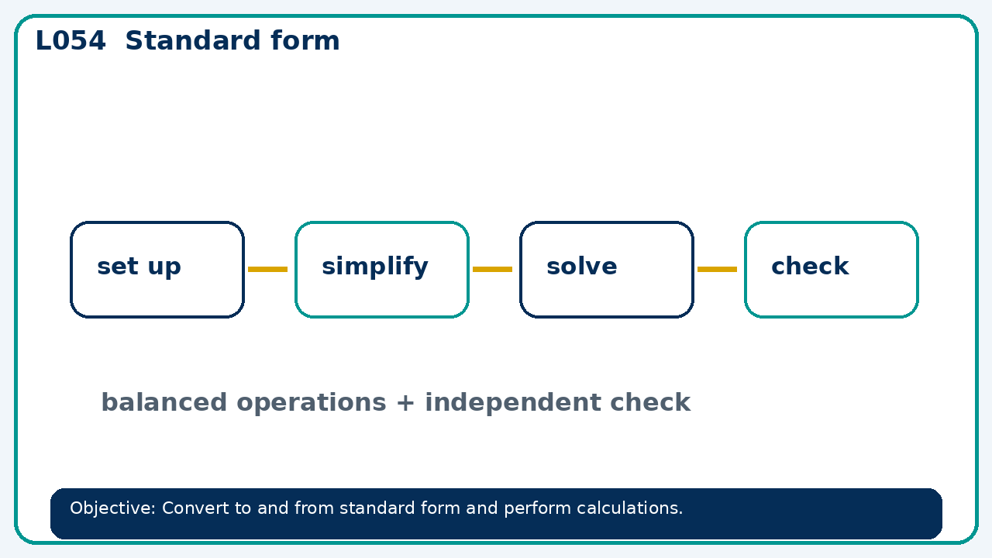

Core knowledge
- Connect powers of ten to place value; check whether the coefficient is in range

Method checklist
- Identify what the question is asking.
- Choose the relevant representation or method.
- Show working clearly and label units.
- Check the answer against the original context.
- Write one sentence explaining why the answer is reasonable.

Common error to avoid
- Explain why 12×10⁴ is not in standard form and rewrite it.

