
Reach for the Star | GCSE Mathematics 1MA1 | L054

Learner workbook: Standard form
Objective: Convert to and from standard form and perform calculations.
Calculator condition: Calculator allowed where labelled; non-calculator reasoning remains required.
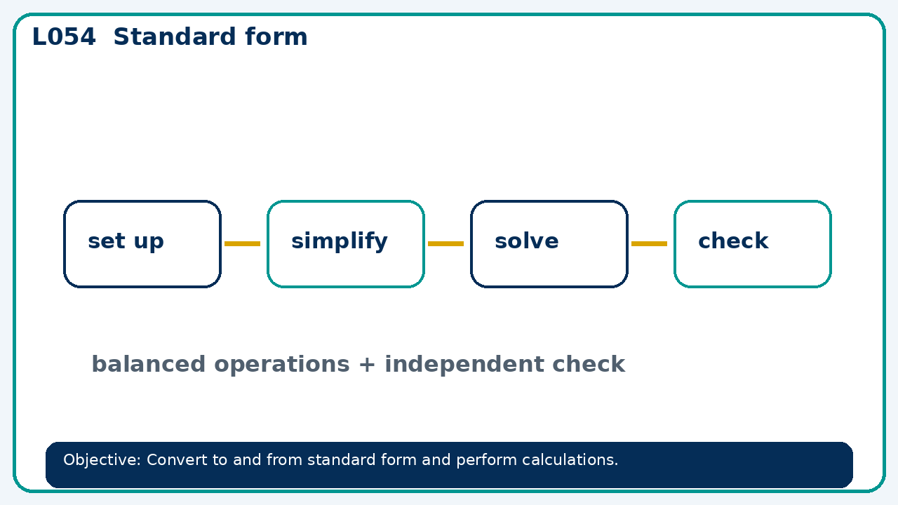

Connect & Check
- State the objective and timeline. Retrieve powers roots and index laws or a prerequisite. Diagnose a common error before modelling.
- Write one starting question you want answered today.

Choose your route
Route A: Visual  Use a diagram, graph, table or annotation first. | Route B: Method  Use a worked method, formula or calculation chain first. | Route C: Explain  Start with words: what is known, what is changing, and why.

Share
- Pairs compare methods or predict a result for standard form. Ask for a reason, not only an answer.

Present
- Connect powers of ten to place value; check whether the coefficient is in range

Apply: supported to independent
Recall: Retrieve the key fact or method needed for standard form.
Working: ______________________________________________________________
Check/explanation: ____________________________________________________
Core practice: Write 0.00000056 in standard form, then multiply it by 3×10⁵.
Working: ______________________________________________________________
Check/explanation: ____________________________________________________
Reasoning: Explain why 12×10⁴ is not in standard form and rewrite it.
Working: ______________________________________________________________
Check/explanation: ____________________________________________________
Exam-style: Solve an exam-style problem involving standard form. Show working, include a check and interpret your answer.
Working: ______________________________________________________________
Check/explanation: ____________________________________________________

Recall & Review
- Revisit the objective. Learners solve a fresh item without prompts, explain a check, correct one error and record the next practice.
WWW: ________________________________ EBI: ________________________________

Recall & Review: feedback and extension integration
Lesson L054: Standard form
Objective: Convert to and from standard form and perform calculations.
Timing for a 60-minute lesson
0-7 Connect & Check; 7-14 Share; 14-25 Present/model; 25-44 Apply route choice/practice; 44-52 independent exam-style check; 52-60 Recall & Review, WWW/EBI and next step.
Recall & Review evidence
At the end of the lesson, solve a fresh question without prompts, explain one check, correct one error and record the next practice step.
What Went Well (WWW)
I selected an efficient numerical method, showed the key steps clearly and checked the sign, size or accuracy of my answer.
Even Better If (EBI)
I will make the place-value, sign or operation decision explicit and use estimation or an inverse calculation to check a fresh question.
Integrated stretch and deep challenge
Stretch: Write 0.00000056 in standard form, then multiply it by 3×10⁵.
Deep challenge: Explain why 12×10⁴ is not in standard form and rewrite it.
My next-step response

