
Reach for the Star | GCSE Mathematics 1MA1 | L055

Knowledge organiser: Rounding error intervals and bounds
Objective: Describe rounding intervals and reason about limits of accuracy.
Calculator condition: Calculator allowed where labelled; non-calculator reasoning remains required.
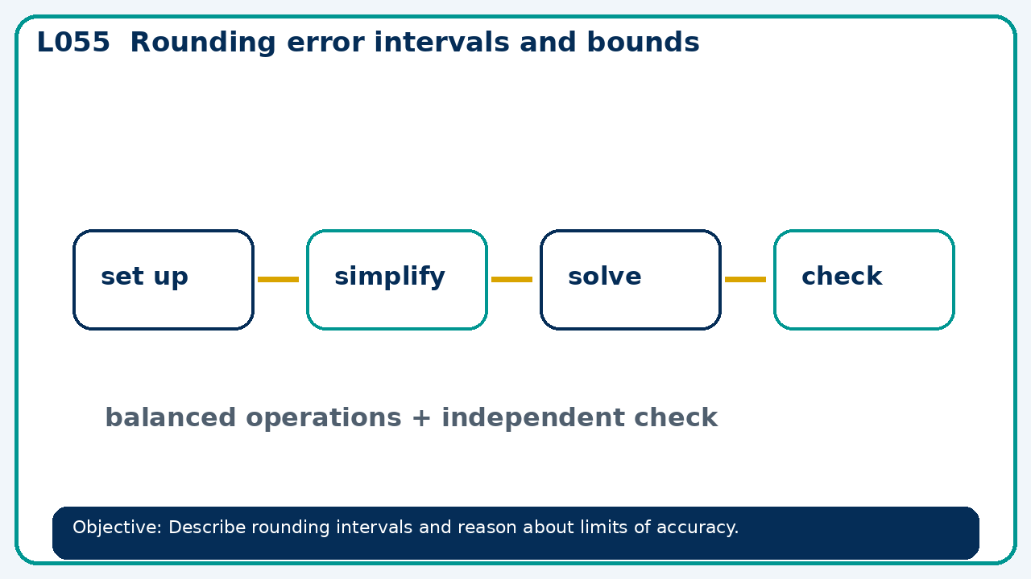

Core knowledge
- Use number lines to distinguish included and excluded endpoints

Method checklist
- Identify what the question is asking.
- Choose the relevant representation or method.
- Show working clearly and label units.
- Check the answer against the original context.
- Write one sentence explaining why the answer is reasonable.

Common error to avoid
- A rounded length is 10 cm to nearest cm. Is 10.5 cm included? Explain.

