
Reach for the Star | GCSE Mathematics 1MA1 | L056

Knowledge organiser: Number accuracy pathway
Objective: Select appropriate exact or approximate forms and explain accuracy.
Calculator condition: Non-calculator core; calculator optional only for checking where labelled.
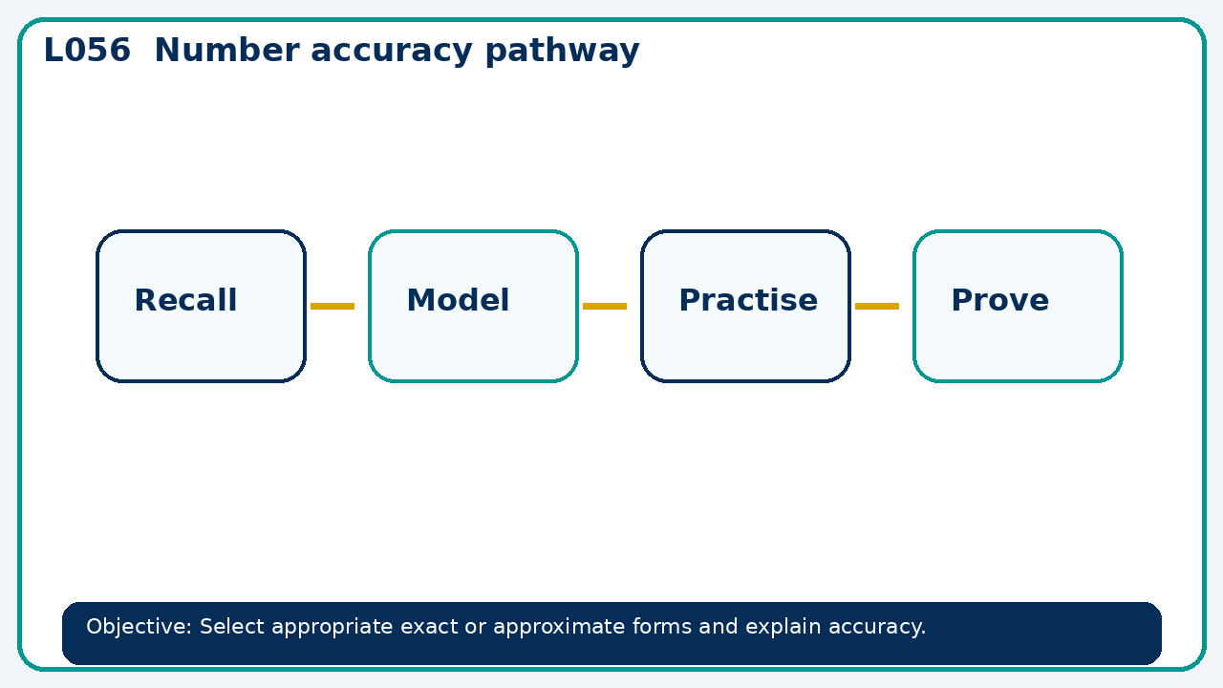

Core knowledge
- Foundation: rounding and estimation repair.
- Higher: surds, rationalisation and calculated bounds

Method checklist
- Identify what the question is asking.
- Choose the relevant representation or method.
- Show working clearly and label units.
- Check the answer against the original context.
- Write one sentence explaining why the answer is reasonable.

Common error to avoid
- A measurement rounds to 1.20 to two decimal places. State the interval and explain why 1.205 is excluded.

