
Reach for the Star | GCSE Mathematics 1MA1 | L056

Learner workbook: Number accuracy pathway
Objective: Select appropriate exact or approximate forms and explain accuracy.
Calculator condition: Non-calculator core; calculator optional only for checking where labelled.
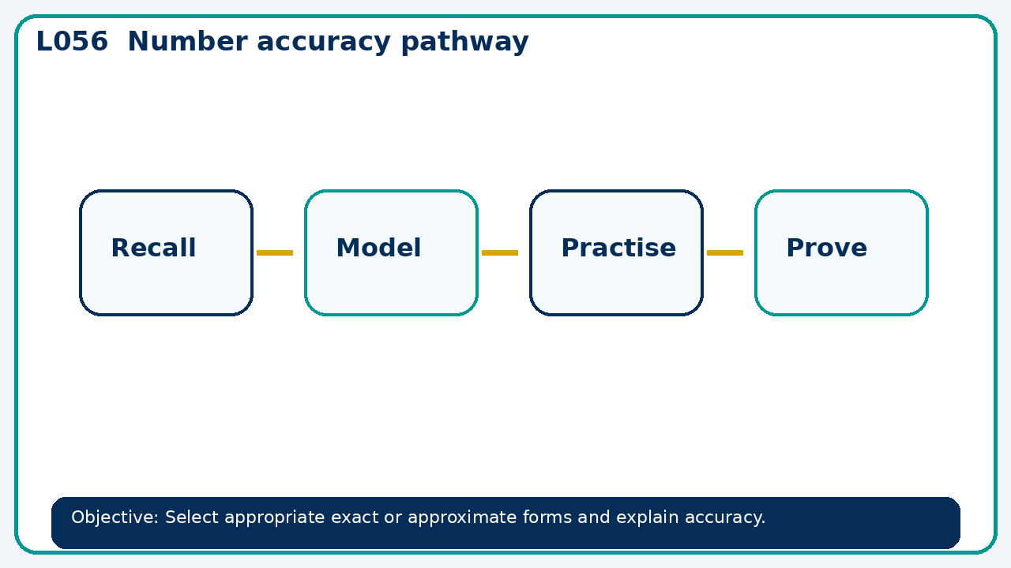

Connect & Check
- State the objective and timeline. Retrieve rounding error intervals and bounds or a prerequisite. Diagnose a common error before modelling.
- Write one starting question you want answered today.

Choose your route
Route A: Visual  Use a diagram, graph, table or annotation first. | Route B: Method  Use a worked method, formula or calculation chain first. | Route C: Explain  Start with words: what is known, what is changing, and why.

Share
- Pairs compare methods or predict a result for number accuracy pathway. Ask for a reason, not only an answer.

Present
- Foundation: rounding and estimation repair.
- Higher: surds, rationalisation and calculated bounds

Apply: supported to independent
Recall: Retrieve the key fact or method needed for number accuracy pathway.
Working: ______________________________________________________________
Check/explanation: ____________________________________________________
Core practice: Estimate 398×0.051 to one significant figure, then calculate exactly.
Working: ______________________________________________________________
Check/explanation: ____________________________________________________
Reasoning: A measurement rounds to 1.20 to two decimal places. State the interval and explain why 1.205 is excluded.
Working: ______________________________________________________________
Check/explanation: ____________________________________________________
Exam-style: Solve an exam-style problem involving number accuracy pathway. Show working, include a check and interpret your answer.
Working: ______________________________________________________________
Check/explanation: ____________________________________________________

Recall & Review
- Revisit the objective. Learners solve a fresh item without prompts, explain a check, correct one error and record the next practice.
WWW: ________________________________ EBI: ________________________________

Recall & Review: feedback and extension integration
Lesson L056: Number accuracy pathway
Objective: Select appropriate exact or approximate forms and explain accuracy.
Timing for a 60-minute lesson
0-7 Connect & Check; 7-14 Share; 14-25 Present/model; 25-44 Apply route choice/practice; 44-52 independent exam-style check; 52-60 Recall & Review, WWW/EBI and next step.
Recall & Review evidence
At the end of the lesson, solve a fresh question without prompts, explain one check, correct one error and record the next practice step.
What Went Well (WWW)
I selected an efficient numerical method, showed the key steps clearly and checked the sign, size or accuracy of my answer.
Even Better If (EBI)
I will make the place-value, sign or operation decision explicit and use estimation or an inverse calculation to check a fresh question.
Integrated stretch and deep challenge
Stretch: Estimate 398×0.051 to one significant figure, then calculate exactly.
Deep challenge: A measurement rounds to 1.20 to two decimal places. State the interval and explain why 1.205 is excluded.
My next-step response

