
Reach for the Star | GCSE Mathematics 1MA1 | L057

Knowledge organiser: Quadratic expressions
Objective: Expand and factorise quadratic expressions using structure.
Calculator condition: Calculator allowed where labelled; non-calculator reasoning remains required.
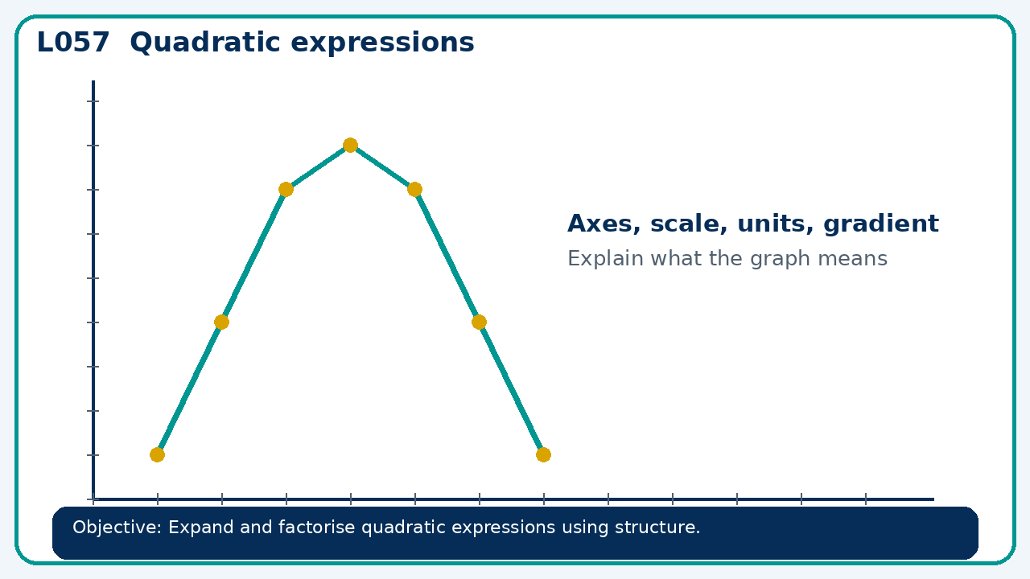

Core knowledge
- Connect area models to products; reverse expansion to check factors

Method checklist
- Identify what the question is asking.
- Choose the relevant representation or method.
- Show working clearly and label units.
- Check the answer against the original context.
- Write one sentence explaining why the answer is reasonable.

Common error to avoid
- A learner writes (x−4)(x+2)=x²−8. Find the missing terms.

