
Reach for the Star | GCSE Mathematics 1MA1 | L058

Knowledge organiser: Quadratic graphs and roots
Objective: Plot quadratic graphs and interpret roots and key features.
Calculator condition: Calculator allowed where labelled; non-calculator reasoning remains required.
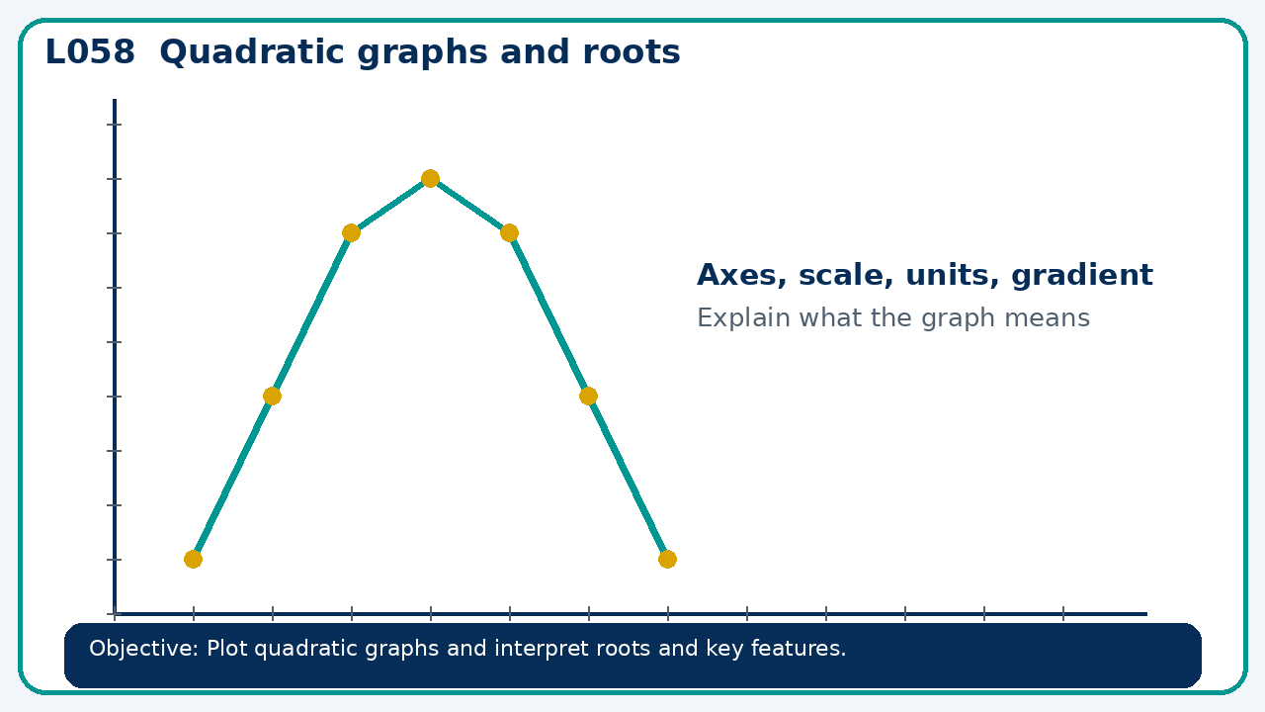

Core knowledge
- Link factors, zeros and intercepts; distinguish graph estimates from exact roots

Method checklist
- Identify what the question is asking.
- Choose the relevant representation or method.
- Show working clearly and label units.
- Check the answer against the original context.
- Write one sentence explaining why the answer is reasonable.

Common error to avoid
- A quadratic has roots −1 and 5. Write a monic equation and state its axis of symmetry.

