
Reach for the Star | GCSE Mathematics 1MA1 | L058

Learner workbook: Quadratic graphs and roots
Objective: Plot quadratic graphs and interpret roots and key features.
Calculator condition: Calculator allowed where labelled; non-calculator reasoning remains required.
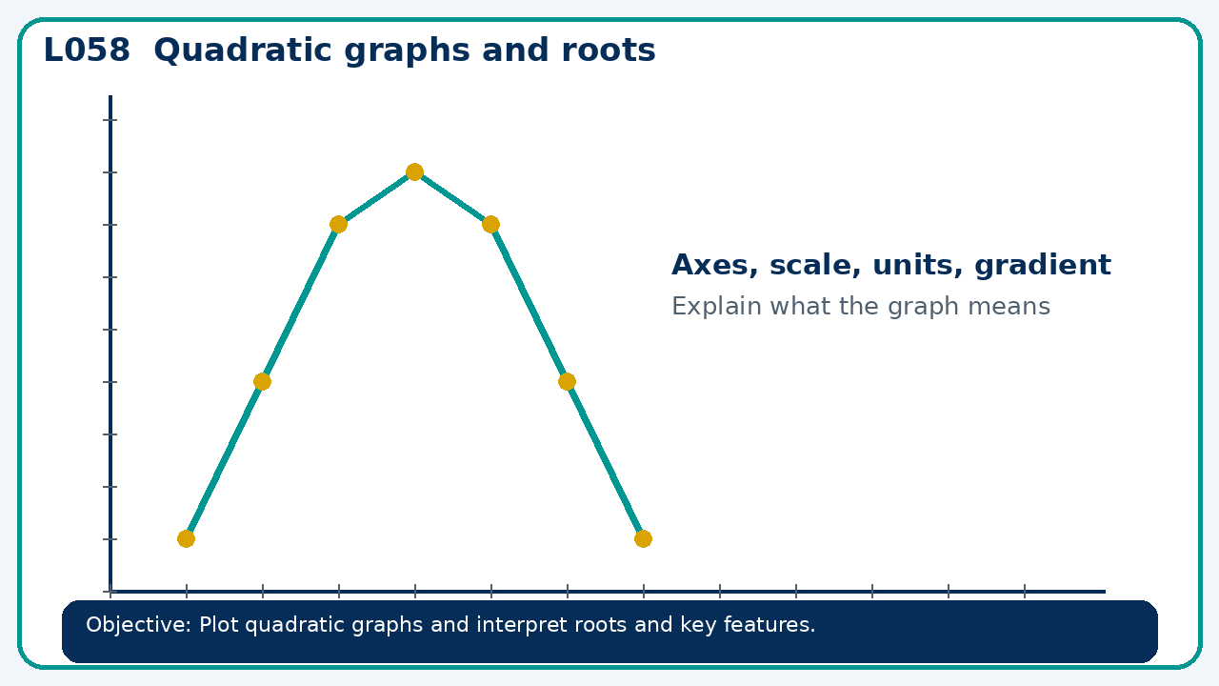

Connect & Check
- State the objective and timeline. Retrieve quadratic expressions or a prerequisite. Diagnose a common error before modelling.
- Write one starting question you want answered today.

Choose your route
Route A: Visual  Use a diagram, graph, table or annotation first. | Route B: Method  Use a worked method, formula or calculation chain first. | Route C: Explain  Start with words: what is known, what is changing, and why.

Share
- Pairs compare methods or predict a result for quadratic graphs and roots. Ask for a reason, not only an answer.

Present
- Link factors, zeros and intercepts; distinguish graph estimates from exact roots

Apply: supported to independent
Recall: Retrieve the key fact or method needed for quadratic graphs and roots.
Working: ______________________________________________________________
Check/explanation: ____________________________________________________
Core practice: For y=x²−4x+3, find both roots and the turning point.
Working: ______________________________________________________________
Check/explanation: ____________________________________________________
Reasoning: A quadratic has roots −1 and 5. Write a monic equation and state its axis of symmetry.
Working: ______________________________________________________________
Check/explanation: ____________________________________________________
Exam-style: A graph is drawn for a real context. Interpret the gradient, intercept or area as appropriate. State units and justify your answer.
Working: ______________________________________________________________
Check/explanation: ____________________________________________________

Recall & Review
- Revisit the objective. Learners solve a fresh item without prompts, explain a check, correct one error and record the next practice.
WWW: ________________________________ EBI: ________________________________

Recall & Review: feedback and extension integration
Lesson L058: Quadratic graphs and roots
Objective: Plot quadratic graphs and interpret roots and key features.
Timing for a 60-minute lesson
0-7 Connect & Check; 7-14 Share; 14-25 Present/model; 25-44 Apply route choice/practice; 44-52 independent exam-style check; 52-60 Recall & Review, WWW/EBI and next step.
Recall & Review evidence
At the end of the lesson, solve a fresh question without prompts, explain one check, correct one error and record the next practice step.
What Went Well (WWW)
I represented the algebraic structure accurately, kept each transformation valid and checked the result by substitution, graph or equivalent reasoning.
Even Better If (EBI)
I will show the missing inverse operation or algebraic step, keep signs and brackets accurate and test the result in the original relationship.
Integrated stretch and deep challenge
Stretch: For y=x²−4x+3, find both roots and the turning point.
Deep challenge: A quadratic has roots −1 and 5. Write a monic equation and state its axis of symmetry.
My next-step response

