
Reach for the Star | GCSE Mathematics 1MA1 | L059

Knowledge organiser: Solving quadratics
Objective: Solve quadratic equations using tier-appropriate methods.
Calculator condition: Calculator allowed where labelled; non-calculator reasoning remains required.
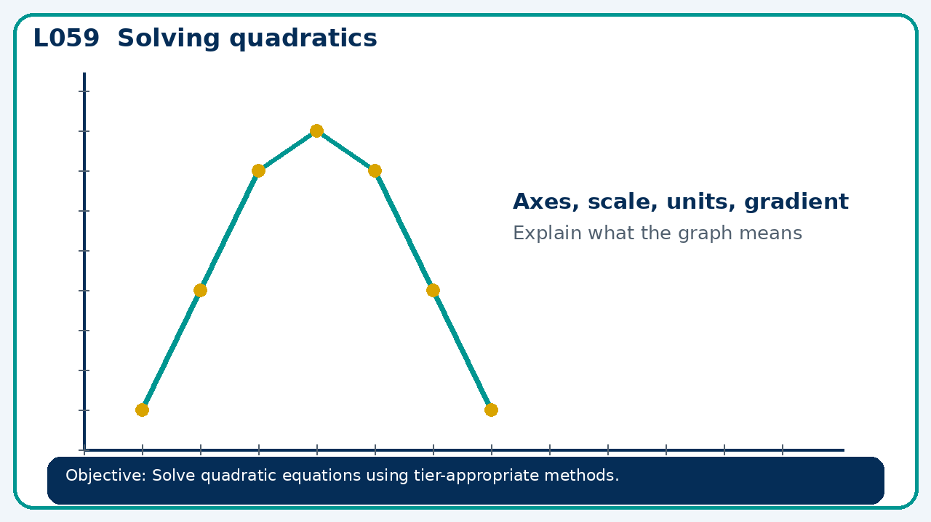

Core knowledge
- Start with factorisation and the zero-product property; Higher: formula and completing the square

Method checklist
- Identify what the question is asking.
- Choose the relevant representation or method.
- Show working clearly and label units.
- Check the answer against the original context.
- Write one sentence explaining why the answer is reasonable.

Common error to avoid
- Explain why dividing x²=9 by x can lose a solution.

