
Reach for the Star | GCSE Mathematics 1MA1 | L060

Knowledge organiser: Algebra pathway and repair
Objective: Choose an algebraic method and repair an identified misconception.
Calculator condition: Non-calculator core; calculator optional only for checking where labelled.
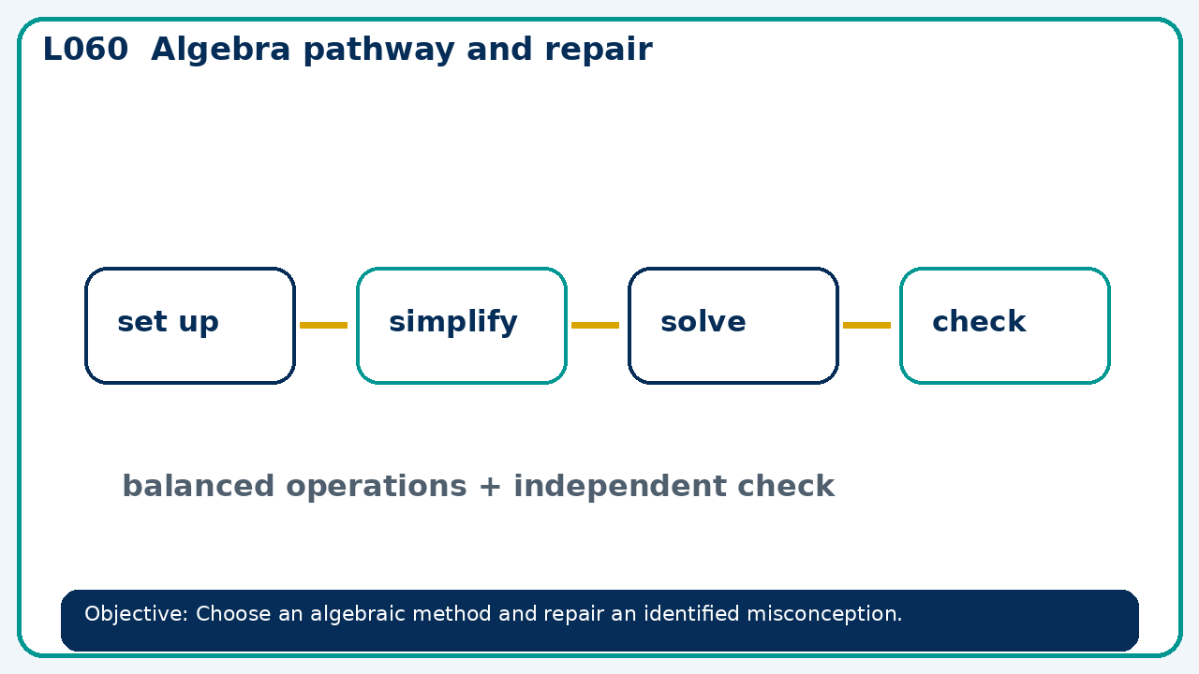

Core knowledge
- Foundation: linear and simple quadratic work.
- Higher: compare quadratic methods and forms

Method checklist
- Identify what the question is asking.
- Choose the relevant representation or method.
- Show working clearly and label units.
- Check the answer against the original context.
- Write one sentence explaining why the answer is reasonable.

Common error to avoid
- A learner cancels x from x²+x=0 and gets x=−1 only. Find every solution.

